Kent and Medway Fire and Rescue Authority

Budget Book
And
Medium Term Financial Plan
2022/23 – 2025/26

This Budget Book details the assumptions used by the Authority for developing the 2022/23 budget, the estimates used for later years and explains the proposals contained within the Medium Term Financial Plan.
Budget estimates reflect the implementation of the initiatives outlined in the Customer Safety Plan 2021-2031 (and six supporting strategies).

Contents
THE BUDGET STRATEGY 2022/23 - Foreword 1
BUILDING THE 2022/23 REVENUE BUDGET 2 - 11
Revenue Budget Changes 2021/22 to 2022/23 2 - 3
2022/23 Pressures Summary 4 - 5
2022/23 Savings Summary 6
2022/23 Subjective and Functional Budget Presentation 7 - 8
2022/23 Additional Subjective Analysis - Employee Pay Budgets ..9 - 10
2022/23 Additional Subjective Analysis - Reserve Transfers and Income ………………..11
FUNDING THE 2022/23 REVENUE BUDGET 12 - 16
2022/23 Grant Funded Expenditure………………………………………………...…………12
2022/23 Sources of Funding the Net Revenue Budget 13 - 14
Council Tax and Business Rates Income – Additional Information 15 - 16
REVENUE RESERVES SUMMARY 17 - 18
MEDIUM TERM FINANCIAL PLAN 2022/23 – 2025/26 ……………………………………... 19 - 21
Revenue Budget Assumptions (Funding, Pressures and Savings) ………………… 19 - 20
Summary Revenue Budget Estimates …………………………………………………..……20
Analysis of Additional Council Tax Income……………………………………………………21
MEDIUM TERM INFRASTRUCTURE PLAN 2022/23 - 2025/26 ……………………………. 22 - 26
Medium Term Infrastructure Plan ………………………………………………………. 22 - 24
Infrastructure Plan Funding and Reserve Balances ………………………………….. 25 - 26
WHAT DO YOU GET FOR YOUR MONEY? ……………………………………………………….. 27

THE BUDGET STRATEGY 2022/23 - Foreword
The Purpose of the Budget Strategy

Striving to achieve equality of access to our services for everyone who lives in or travels through Kent and Medway, through targeted engagement and using different approaches - with an aim of reaching specific groups who may not be aware of, or currently who choose not to access our services.
Equality of access
Examples of Key Themes in the Budget Strategy
Ensuring that people’s needs are at the centre of our response, starting with the call-handling team and ending with post-incident care, advice and support and learning from incidents. Alongside a drive to demonstrate that we are a professional organisation supported by initiatives such as membership of the Institute of Fire Engineers and access to online learning for operational and support staff.
On 27 October 2021 the Chancellor presented the Autumn Budget and Spending Review to Parliament. Total departmental spending is set to grow in real terms at 3.8% a year on average from 2021/22 to 2024/25. Although the Spending Review set departmental budgets up to 2024/25, the Provisional Local Government Finance Settlement, announced on 16 December 2021, only provided funding figures for the Authority for the financial year 2022/23. It is anticipated that funding for 2023/24 and 2024/25 will be determined as part of a Fair Funding Review, meaning that there is currently some uncertainty regarding government funding levels beyond 2022/23.
The provisional settlement confirmed that the Business Rates multiplier will be frozen for 2022/23, meaning Baseline Funding Levels will be rolled forward from 2021/22 with no uplift. Revenue Support Grant will be uplifted by the September 2021 Consumer Price Index providing an increase of 3.1% or £198k of additional grant funding for 2022/23. A new one-off Services Grant was also announced for 2022/23, confirmed at £1.027m for the Authority, and although not ring-fenced a proportion of the allocation is intended to fund the national insurance increase (1.25%). The Government will continue to compensate the Authority for the under-indexation of the Business Rates multiplier, meaning the Section 31 grant will increase by £427k in 2022/23 as a result of this policy decision. The final settlement is expected to be announced sometime in February 2022 and it is anticipated that the final settlement will be in line with the provisional settlement.
To ensure that medium-term budget proposals are sustainable, and in light of the responses to the council tax consultation, it is proposed that council tax should be increased by 1.89%, resulting in an annual increase for a Band D property of £1.53 per year, making the Band D council tax charge £82.35 for 2022/23.
Funding the 2022/23 Budget
The Authority’s budget supports the delivery of the initiatives detailed in the Customer Safety Plan 2021-2031 (and six supporting strategies). When determining spending proposals and Council Tax increases, due consideration is taken of all potential cost pressures and possible savings alongside anticipated funding changes over the medium term.

Infrastructure Investment
Significant investment in the replacement of fire engines, specialist vehicles, pool and response cars. Improving live fire training facilities and other estate redevelopments. Upgrading IT software and core infrastructure, including the implementation of a single software solution for Operations, Business Safety and Customer Safety providing increased visibility of risk data.
Operational excellence
Ann Millington
Chief Executive

BUILDING THE 2022/23 REVENUE BUDGET

Revenue Budget Changes 2021/22 to 2022/23
The Table below summarises the incremental adjustments made to the 2021/22 base revenue budget in order to determine the net revenue budget requirement for 2022/23:-
 | £’000 | £’000
Base budget brought forward from 2021/22 |  | 74,849
Pay and pensions related cost pressures (see pages 4 and 5)
Pay growth (pay awards, pay increments and new posts) | 4,398
Local Government Pension Scheme employer rate increase | 148
National insurance employer rate increase | 339
Pensions – injury and ill health | 209
Total pay and pensions related cost pressures for 2022/23 |  | 5,094
Non-pay pressures (see page 5)
Inflationary price increases | 719
Other identified pressures | 515
Total non-pay pressures for 2022/23 |  | 1,234
Savings (see page 6)
Pay Savings | -667
Discretional price increase removal | -373
Business Rates | -200
Investment Income | -147
Capital Financing | -141
Other non-pay savings | -241
Total savings for 2022/23 |  | -1,769
2022/23 base revenue budget |  | 79,408
Reserve funding adjustments (see page 3)
Transfer from Earmarked Reserves - Local Tax Income Guarantee | -234
Transfer from Earmarked Reserves - 21/22 Expanded Retail Reliefs | -1,529
Transfer from Earmarked Reserves – Base Savings Deferred | -426
Transfer to General Reserve | 210
Total reserve funding adjustments in 2022/23 |  | -1,979
Net revenue budget requirement for 2022/23 |  | 77,429

BUILDING THE 2022/23 REVENUE BUDGET

Revenue Budget Changes 2021/22 to 2022/23

Reserve Adjustments – Additional Explanations

An explanation detailing the reason for each of the reserve adjustments listed on the previous page is provided below:

Transfer from Earmarked Reserves – Local Tax Income Guarantee – The Government has provided the Authority with grant funding to cover 75% of the irrecoverable Covid-19 related losses on the 2020/21 Collection Funds. These losses are spread in Medway and Kent District Councils Collection Funds over the three financial years 2021/22, 2022/23 and 2023/24. The government grant funding has therefore been put into an Earmarked Reserve and will be released from the reserve to coincide with the recovery of the Collection Fund deficits by Medway and Kent District Councils. Therefore, £234k is to be released from the reserve in 2022/23.

Transfer from Earmarked Reserves – 21/22 Expanded Retails Reliefs - Due to the Covid-19 pandemic the Government granted additional Business Rates reliefs after the National Non-Domestic Rates (NNDR1) returns were completed and budgets had been set for 2021/22. As a consequence, a large deficit is reported against the Business Rates Collection Fund in 2022/23. The Government will reimburse authorities by paying a Section 31 grant to fully compensate for the lost income due to this policy decision. The Section 31 grant is accounted for in 2021/22 and a corresponding amount put into reserves in 2021/22 to be released in 2022/23 to match the reporting of the Collection Fund deficits caused by these additional reliefs.

Transfer from Earmarked Reserves – Base Savings Deferred - To take account of timing differences between spending requirements, funding and income sources and delivery of base budget savings, the 2022/23 budget includes a one-off transfer from the Insurance and Resource Reserve. The £426k transfer from the reserve will reduce the balance held in the reserve from £2.841m to £2.415m, excluding any transfer that may be made to the reserve following confirmation of the final revenue budget underspend for 2021/22.

Transfer to General Reserve – The amount to be transferred to the General Reserve in 2022/23 is £210k, increasing the balance of the reserve to £3.970m for 2022/23. This will ensure that the General Reserve balance is maintained at approximately 5% of the base revenue budget, as set out in the 2022/23 Reserves Strategy.

BUILDING THE 2022/23 REVENUE BUDGET

2022/23 Pressures Summary

Pay and Pensions Related Cost Pressures
The Authority uses an incremental approach to develop the budget, so the 2021/22 base revenue budget has been adjusted to reflect the pressures identified below:-
Pay and Pensions Related Costs Pressures | £’000
Pay Awards for 2021/22  When the 2021/22 budget was set it was assumed that pay increases would be “paused” for 2021/22, reflecting the government policy on public sector pay increases at the time. Subsequently, pay awards of 1.5% were agreed for operational staff and principal officers, whilst an offer of 1.75% for corporate staff has, so far, been rejected by the trade unions. It is therefore estimated that an uplift of 1.75% will need to be reflected in the 2022/23 budget for corporate staff, along with the 1.5% pay awards that are already in payment for operational staff and principal officers. | 909
Pay Awards for 2022/23  A pay award of 3% has been assumed for all staff groups for 2022/23. A full year impact has been assumed for corporate staff and principle officers, whilst it is assumed that the operational staff pay award will continue to be applied from the 1st July. | 1,449
Staff Increments  Staff on green book terms and conditions will generally receive an annual incremental pay scale increase until they reach the top of the pay grade for the job role. | 214
Restructures and Additional Posts  There have been various restructures and new posts agreed across a variety of teams during 2021/22 including in; Operational Response, Building Safety, Customer Safety, People and Learning, Finance and Procurement. In many cases these changes have been implemented to keep up with changing demands and to ensure that the service remains fit for the future. | 1,767
Bank Holiday Adjustment  The budget is adjusted to account for the number of bank holiday days that fall in the financial year. As there is an additional bank holiday in 2022/23 (compared to 2021/22) an amount is added to the budget to fund the cost of payments to staff (generally oncall and wholetime operational colleagues) who work on the additional bank holiday. | 46
Apprenticeship Scheme Levy  The apprenticeship levy is calculated as a percentage of pay so the budget has been increased in line with the revised pay budget. | 13
Actuarial Valuations  As a result of the most recent Local Government Pension Scheme (LGPS) valuation the employer contribution rate will increase by 1% each April until the outcome of the next scheme valuation is known, which is expected to be in 2023. Therefore, the LGPS employer contribution rate will increase to 15.5% in 2022/23. | 148

BUILDING THE 2022/23 REVENUE BUDGET

2022/23 Pressures Summary

Pay and Pensions Related Cost Pressures Continued
Pay and Pensions Related Costs Pressures | £’000
Employer National Insurance Increase  There will be a temporary increase of 1.25% in the employer’s national insurance rate in April 2022 to help support the NHS. This will be replaced by a new 1.25% Health and Social Care Levy from April 2023. The government has provided funding for this pressure in 2022/23 via the new one-off Services Grant. |  | 339
Pensions – Ill Health and Injury Liabilities  The budget provides for 2 new ill health retirements in 2022/23, as well as an increase to cover the cost of an inflationary uplift to annual injury pensions already in payment. As the Authority’s contributions towards ill health retirements are paid into the Pension Fund over 3 years this budget could increase or decrease depending on the profile of ill health retirements over the previous 3 years. Additionally, a budget is allocated to fund a reimbursement to the Firefighters Pension Fund where an exceptional discretion has been applied. |  | 209
Total Pay and Pension Related Cost Pressures for 2022/23 |  | 5,094
Non-pay Pressures
Non-Pay Pressures | £’000
Prices  An inflationary increase has been awarded to those budgets that have contracts which commit the Authority to pay an uplifted amount for 2022/23. An increase has also been provided to budgets where there is an unavoidable increase in prices, such as the cost of insurance renewals. For other areas of discretionary spend there is a corresponding saving (see page 6). Gas and electricity budgets have been increased by a total of £193k (a 46% uplift on 2021/22 budgets), based on the latest 2022/23 costing forecasts provided by the supplier. Contractual increases based on CPI have been included at 5% and contractual increases based on RPI have been included at 6%. | 719
Other Pressures  The budget for Microsoft licences has been increased by £180k to provide enhanced cyber security and additional software provision for users. The budget for other software licences has been increased by £86k to provide a full year budget allocation for licences in relation to the Customer and Premises Risk Management project and the Mobile Data Terminals project. Other IT related budgets have been increased by £185k to enable a number of enhancements to be carried out to existing systems and to cover increased costs where additional devices has been purchased. Other minor budget increases total £64k. | 515
Total Non-Pay Pressures for 2022/23 | 1,234
Total Pressures for 2022/23 | 6,328
BUILDING THE 2022/23 REVENUE BUDGET

2022/23 Savings Summary
The Authority uses an incremental approach to develop the budget, so the 2021/22 base revenue budget has been adjusted to reflect the savings identified below:-
Pay Savings | £’000
Vacancy Rate Adjustment  The vacancy rate is reviewed every year by analysing past experience and assessing what the likely scenario is for the coming year. For 2022/23 the vacancy rate will be increased to 2.7% for corporate staff base budgeted posts. | -526
Pension Scheme Changes  Active members of the 1992, 2006 and 2006 Modified pension schemes who had not transitioned into the 2015 scheme by 31 March 2022 will move across to the 2015 scheme on 1 April 2022. Employer contribution rates are lower for the 2015 scheme than they are for the 1992 and 2006 Modified schemes resulting in a budget saving overall. | -141
Total Pay Savings for 2022/23 | -667

Non-pay Savings | £’000
Inflation on Discretionary Spend  Inflationary price increases on areas of discretionary spend, such as stationary, have been removed. | -373
Business Rates  An evaluation of the Authority’s business rates bills has resulted in a reduction in the rateable value of the majority of fire stations across the estate providing a base budget saving. | -200
Investment Income  The budget for investment income has been increased to reflect forecast cash balances and interest rate projections for 2022/23. | -147
Capital Financing  The budget to fund the annual charge made to the revenue account in order to repay what has been borrowed to fund capital expenditure has been reduced for 2022/23 in line with the Treasury Management Strategy. | -141
Annual Review of Budgets  Following the annual review of budgets with Budget Managers additional savings have been identified from their day-to-day revenue budgets. | -241
Total Non-pay Savings for 2022/23 | -1,102
Total Savings for 2022/23 | -1,769

BUILDING THE 2022/23 REVENUE BUDGET

2022/23 Subjective and Functional Budget Presentation
Subjective and Functional Analysis
The Table and Chart below summarise the total net revenue budget of £77.423m for 2022/23 by Subjective and Functional headings:-
(All figures are £’000) | Operational Response and Resilience | Customer Safety, Business Safety and Engagement | Corporate Teams | Pensions, Financing and Other Costs | Total  Net Budget
Employee Pay Costs | 49,950 | 6,368 | 10,049 | - | 66,367
Other Employee Costs | 20 | 45 | 1,299 | - | 1,364
Direct Pension Costs | - | - | - | 2,080 | 2,080
Premises Costs | 42 | 3 | 5,236 | - | 5,281
Transport Costs | 1,918 | 4 | 365 | - | 2,287
Supplies and Services | 2,769 | 551 | 8,069 | 114 | 11,503
Capital Financing | - | - | - | 7,164 | 7,164
Reserve Transfers | -189 | -130 | -521 | -9,629 | -10,469
Income | -6,779 | -75 | -1,102 | -192 | -8,148
Net Budget for 2022/23 | 47,731 | 6,766 | 23,395 | -463 | 77,429
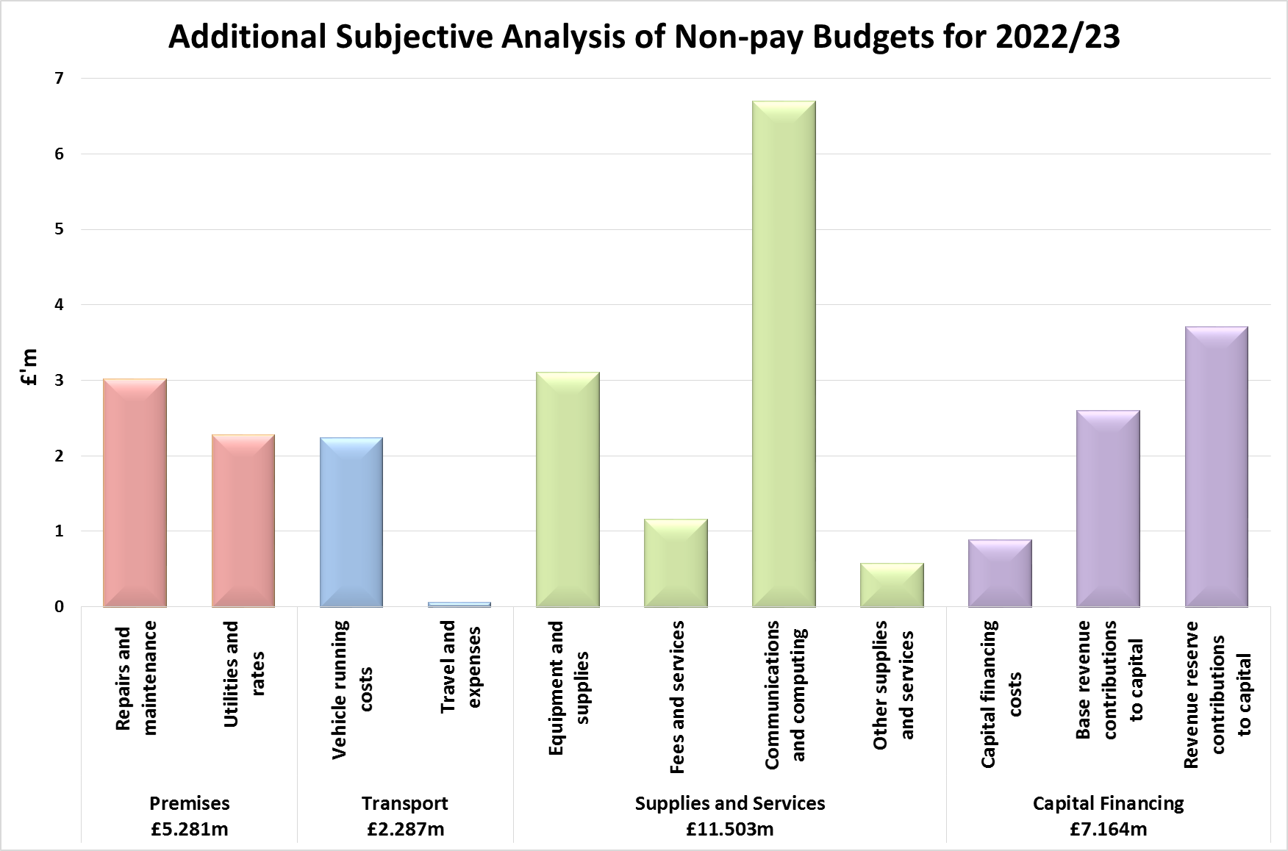
BUILDING THE 2022/23 REVENUE BUDGET

2022/23 Subjective and Functional Budget Presentation
Functional Analysis
The Chart below summarises the 2022/23 budget of £77.429m by Function (in £’000’s) and provides details of the activity areas under each functional heading;

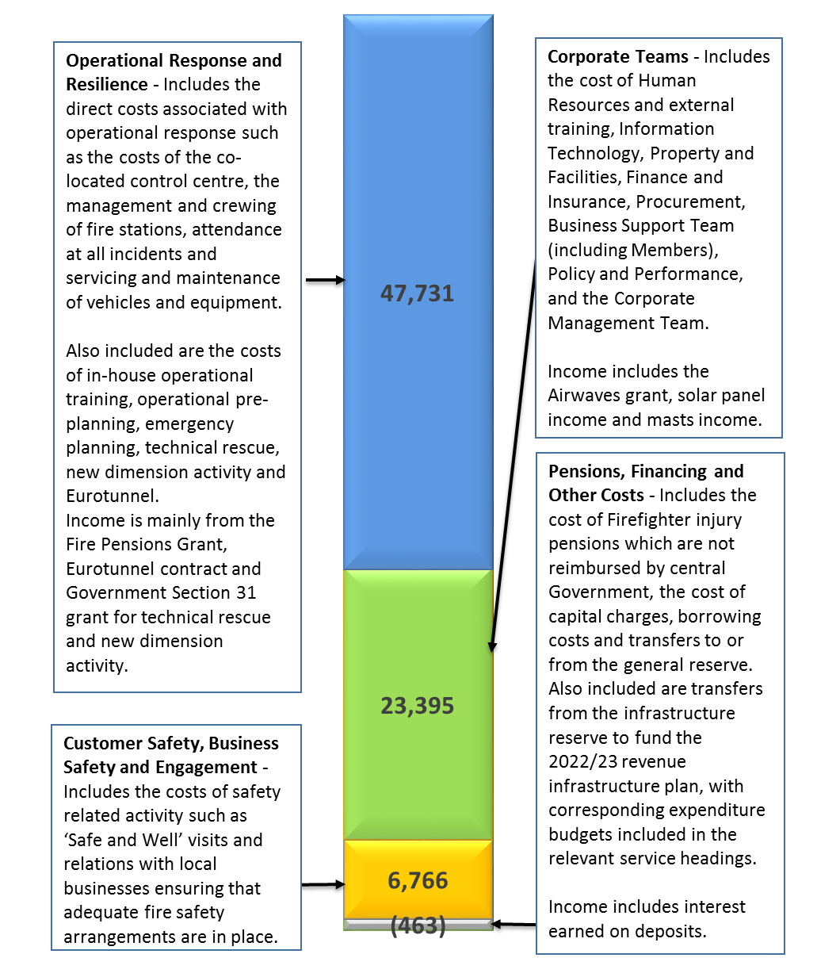
BUILDING THE 2022/23 REVENUE BUDGET

2022/23 Additional Subjective Analysis - Employee Pay Budgets

The budget assumes that pay will be ‘paused’ for all pay groups in 2022/23. Approximately 86% of the net revenue budget relates to staffing costs (£66.367m). The budget allocated to each staff group and details of which personnel sit within each staff group is described below (in £’000’s):-
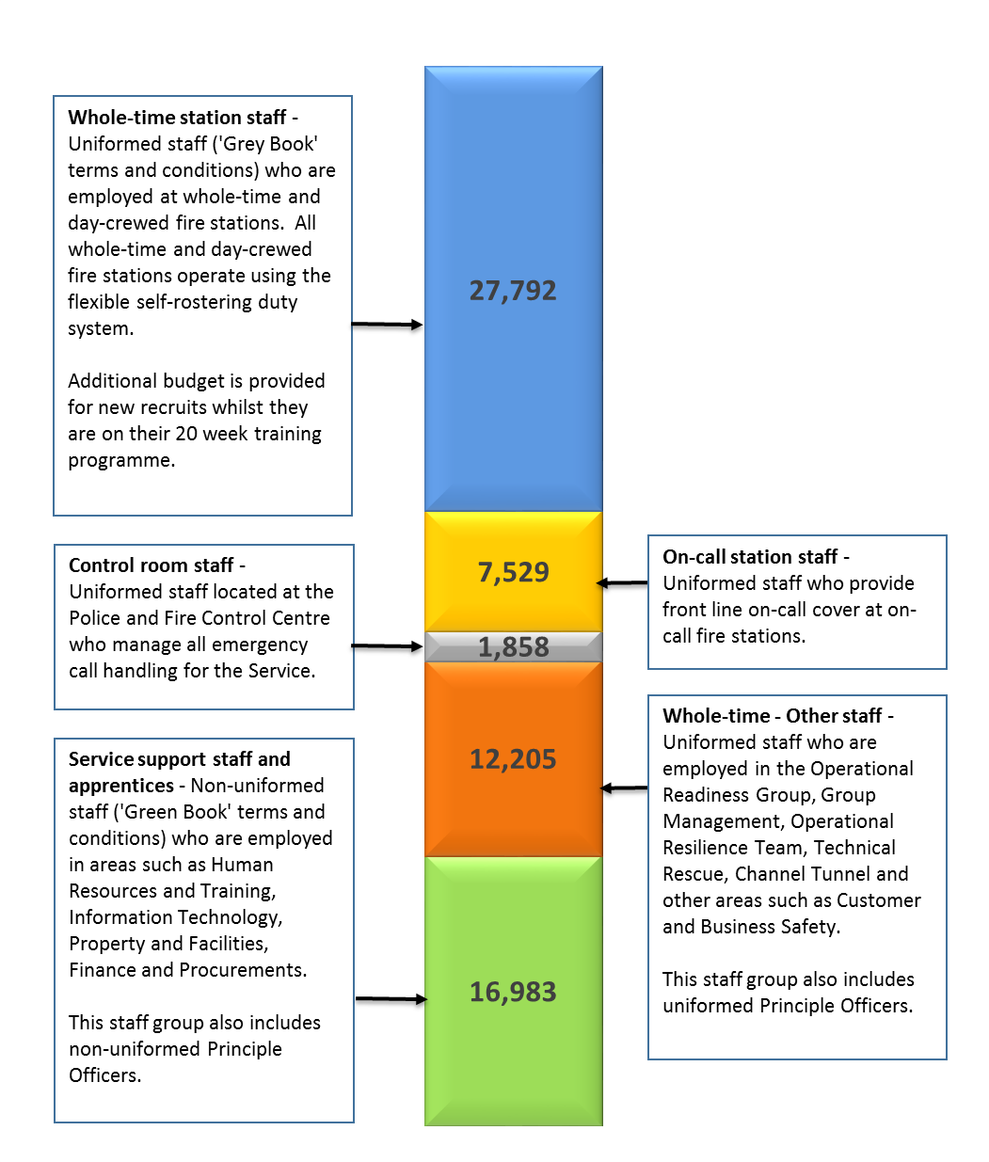
BUILDING THE 2022/23 REVENUE BUDGET

2022/23 Additional Subjective Analysis - Employee Pay Budgets
The Chart below shows the 2022/23 budget and full time equivalent (FTE) for each staff group split by pay, national insurance, employer pension contributions and apprenticeship levy:-
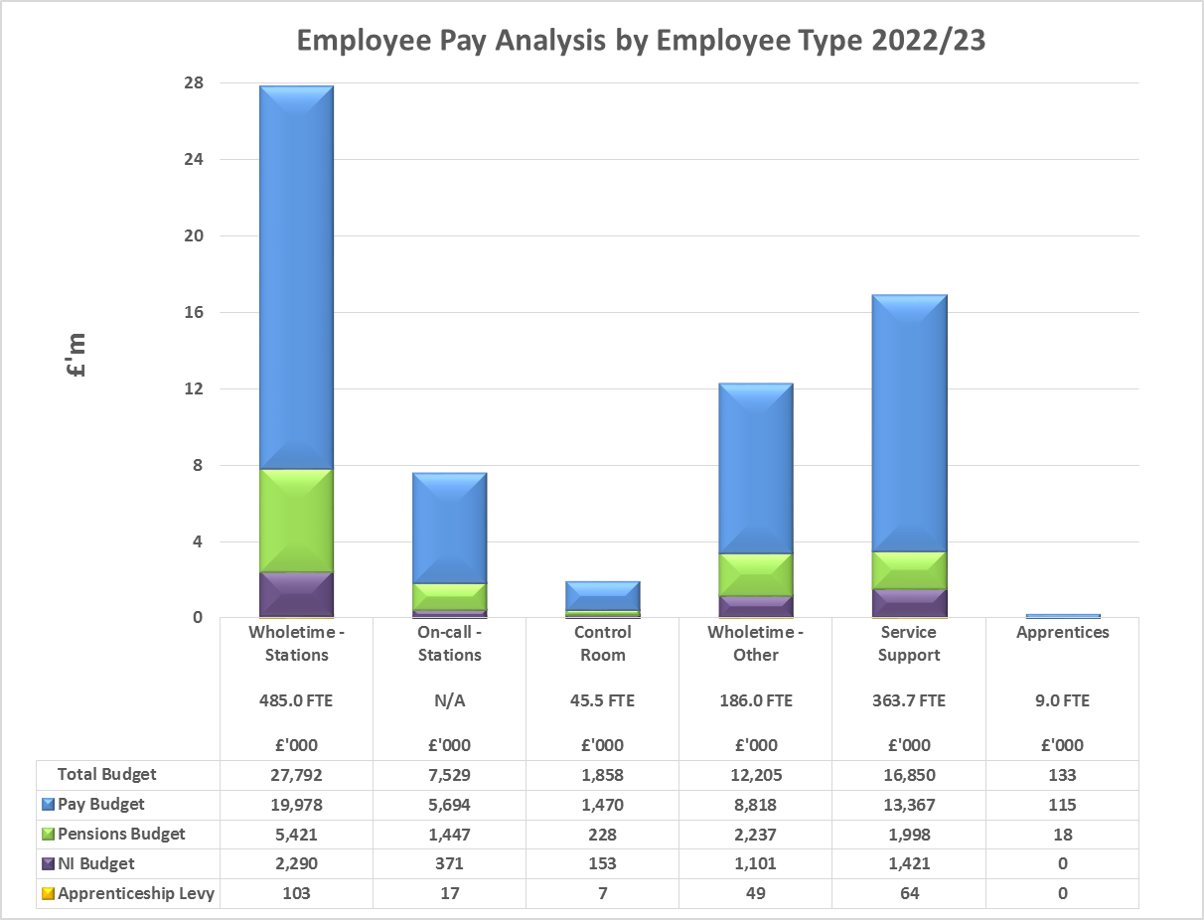
 | Operational Response and Resilience |  | Customer Safety, Business Safety and Engagement |  | Corporate Teams |  | Total  Pay
Pay Group | FTE | Budget | FTE | Budget | FTE | Budget | FTE | Budget
 |  | £’000 |  | £’000 |  | £’000 |  | £’000
WT - Stations | 485.0 | 27,792 | 0.0 | 0 | 0.0 | 0 | 485.0 | 27,792
On-call Stations | N/A | 7,529 | 0.0 | 0 | 0.0 | 0 | N/A | 7,529
Control Room | 45.5 | 1,858 | 0.0 | 0 | 0.0 | 0 | 45.5 | 1,858
WT – Other | 156.0 | 10,001 | 20.0 | 1,212 | 10.0 | 992 | 186.0 | 12,205
Service Support | 66.2 | 2,770 | 125.0 | 5,156 | 172.5 | 8,924 | 363.7 | 16,850
Apprentices | 0.0 | 0 | 0.0 | 0 | 9.0 | 133 | 9.0 | 133
Total Pay Budget | 752.7 | 49,950 | 145.0 | 6,368 | 191.5 | 10,049 | 1,089.2 | 66,367

BUILDING THE 2022/23 REVENUE BUDGET

2022/23 Additional Subjective Analysis - Reserve Transfers and Income

The Chart below provides a breakdown of the total £10.469m reserve transfers included within the net revenue budget of £77.429m along with details of the type of expenditure funded by the reserve transfer:

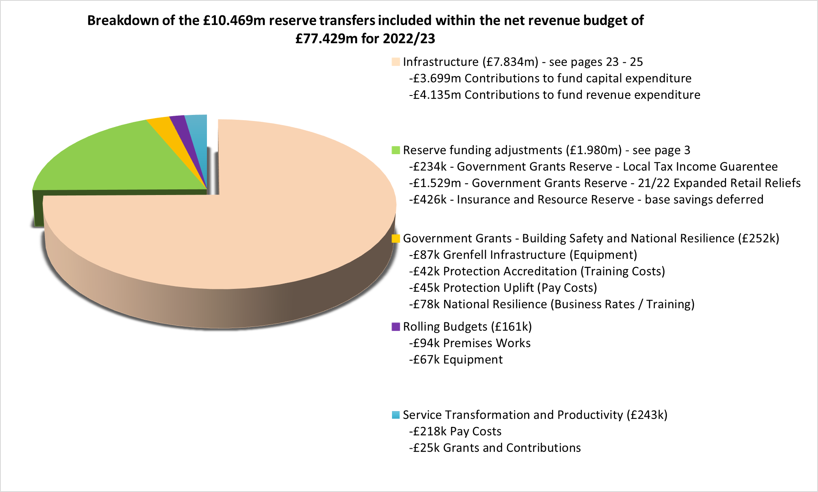

The Chart below provides a breakdown of the total £8.148m income included within the net revenue budget of £77.429m along with details of the type of expenditure funded by this income. Further details regarding the grant income and related expenditure are provided on page 12.

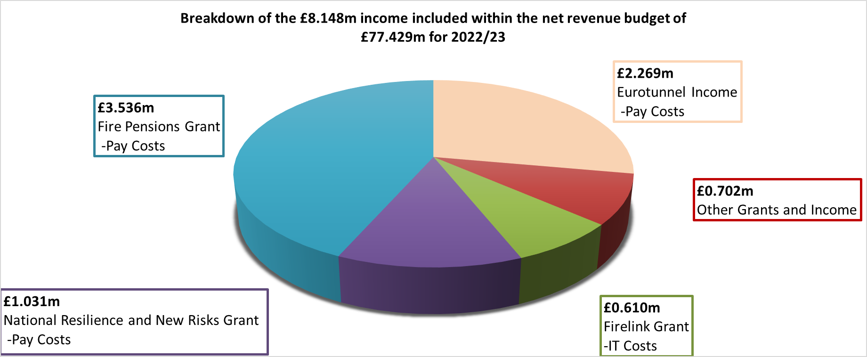
FUNDING THE 2022/23 REVENUE BUDGET

2022/23 Grant Funded Expenditure

In addition to the non-specific Government grants that form part of the Authority’s overall funding (pages 14 and 15), a proportion of the Authority’s annual expenditure is offset by other Government grant income. These grants are usually provided for specific purposes and will therefore be matched to specific grant-related expenditure. Grant funds may be carried forward within Earmarked Reserves if they are not spent in the year in which they are allocated. Detailed below are the estimated grant allocations for 2022/23:-
 | £’000
Fire Pensions Grant - This grant is provided by the Government to cover a proportion of the increase in costs resulting from the significantly higher employer pension contribution rates following the most recent fire pension scheme valuation. The amount of grant has not been confirmed for 2022/23 so the budget has been built on the assumption that the same amount will be received as in the previous three financial years. | 3,536
National Resilience (formerly New Dimension) Grant - This grant covers various resilience activities including the costs of the Technical Rescue team. The amount of grant has not been confirmed for 2022/23 so the budget has been built on the assumption that the same amount will be received as in 2021/22. | 973
New Risks Grant - This grant is paid to Authority’s that maintain a specialist capability to respond to new risks. The amount of grant has not been confirmed for 2022/23 so the budget has been built on the assumption that the same amount will be received as in 2021/22. | 58
Firelink Grant - This grant covers the difference between the annual charge for the FireLink managed service radio scheme and the legacy costs of the now decommissioned radio scheme. Following confirmation of an error in the Government’s calculations for this grant the budget has been reduced by £14k to reflect the new estimate for 2022/23. | 610
Emergency Services Mobile Communication Programme (ESMCP) Grant - This is a National programme to provide the new 4G Emergency Services Network (ESN) to replace the Airwave service currently used by Police, Fire and Rescue and Ambulance services for critical communications. Access to ESN will be via ESN Prime, devices that include critical push to talk, messaging and video. | 122
Apprenticeship Levy - As an employer with a pay bill over £3m the Authority is required to pay funds into the apprentice levy pot each year (see Page 10). Funds can be drawn down to recover training costs for apprentices. Due to timing differences, the amount paid in will be different to the amount drawn down in any given year. | 24

FUNDING THE 2022/23 REVENUE BUDGET

2022/23 Sources of Funding the Net Revenue Budget
For 2022/23 the Authority will receive funding from Council Tax, Business Rates, Collection Funds (prior years Council Tax and Business Rates surplus’ or deficits), Revenue Support Grant, Top-up Grant, Business Rates Section 31 Grant and the new one-off Services Grant, each of which are described below:-
Council Tax Precept - Around 69% of the Authority’s funding comes from Council Tax. The level of Council Tax raised is affected by the level of Council Tax discounts given by billing authorities (Medway Council and Kent District Councils) to Council Taxpayers on low incomes and the level of exemptions granted. The level of discount can also have an impact on collection rates. The amount to be collected from Medway Council and Kent District Councils for 2022/23 is £53.637m.
Business Rates and Top-up Grant - 50% of the income from Business Rates is paid to the Government with the remaining 50% being retained locally, from which fire and rescue authorities (FRAs) receive a 2% local share. Authorities that collect more than the amount specified by the Government will pay a levy to the Government and those that collect less may receive a safety net payment. This Authority is part of a pooling arrangement with Kent County Council and the majority of Kent District Councils. This Authority’s share of the amount to be collected from Medway Council and Kent District Councils for 2022/23 is £6.047m. This amount is lower than in previous years but as the Government is compensating local authorities for the loss of income the reduction is funded by an increase in the Business Rates Section 31 grant for 2022/23. As the Authority’s Business Rates Baseline is less than the Baseline Funding need, the Government will also pay a Top-up Grant which is expected to be £8.514m for 2022/23.
Collection Funds - Each year there can be either a surplus or a deficit on the Collection Funds if the amount collected for Council Tax and Business Rates differs from estimates used when setting budgets in prior years. Overall there is a net deficit of £1.207m to be repaid by the Authority in 2022/23. Covid-19 related deficits from the 2020/21 financial are spread over the three financial years 2021/22, 2022/23 and 2023/24, so a deficit of £371k on Council Tax Collection Funds and a deficit of £136k on Business Rates Collection Funds relate to the 2020/21 financial year. In relation to the 2021/22 financial year there is a surplus of £646k on Council Tax Collection Funds and a deficit of £1.346m on Business Rates Collection Funds. The 2021/22 deficit on Business Rates Collection Funds is due to the additional reliefs granted by the Government after the 2021/22 budgets were set so is funded by Section 31 grant which will be released from reserves in 2022/23 to match the repayment of the deficit to billing authorities.
Revenue Support Grant (RSG) - The Government continues to redistribute funding through the payment of RSG so a grant of £6.655m is expected for 2022/23.
Business Rates Section 31 Grant - The Government continues to provide additional funding to authorities to compensate for the continued impact of the cap on the small business rate multiplier and other reliefs given. The amount of grant expected for 2022/23 is £2.756m.
Services Grant – A new one-off Services Grant will be provided to the Authority in 2022/23. The grant is not ring-fenced but it is intended to provide additional support for services provided plus the cost of the increase in the national insurance rate from April 2022. An amount of £1.027m is expected for 2022/23.
FUNDING THE 2022/23 REVENUE BUDGET
Sources of Funding the Net Revenue Budget for 2022/23
The Chart below shows how the Authority’s funding sources have changed between 2019/20 and 2022/23:-
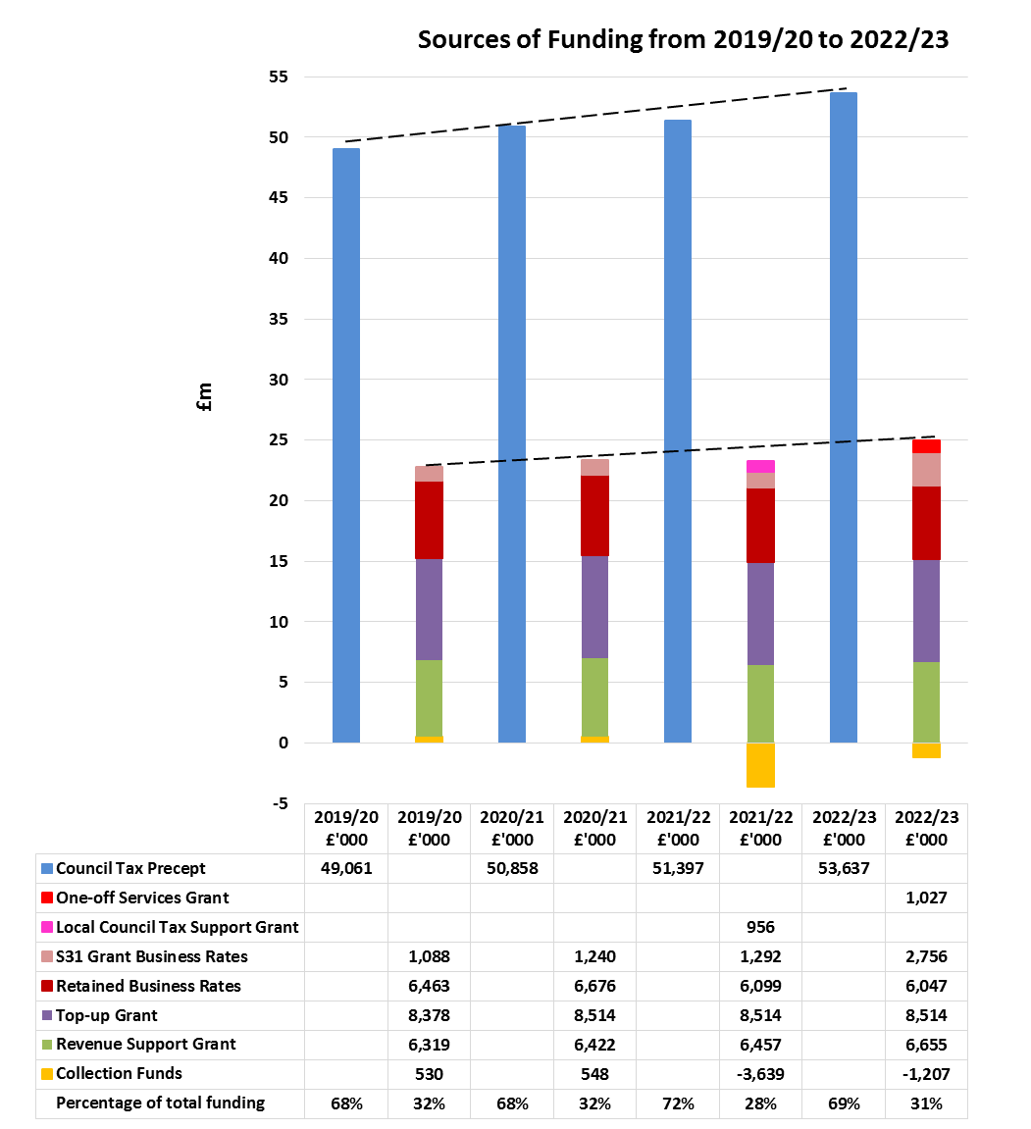
.
FUNDING THE 2022/23 REVENUE BUDGET

Council Tax and Business Rate Income – Additional Information

Council Tax Base - The Authority’s tax base is the sum of the tax bases of the 12 Kent District Councils and Medway Council (billing authorities), and is expressed as the number of equivalent Band D properties. The Council Tax base has increased by 2.42% for 2022/23, following a reduction of 0.85% in 2021/22 due to Covid-19.
Council Tax Referendum Limits - In recent years the Government has set a cap on the amount by which a local authority can increase its Council Tax each year. For 2022/23 Fire and Rescue Authorities whose Band D Council Tax charge for 2021/22 is within the lower quartile of Band D Council Tax charges for all Fire and Rescue Authorities have the flexibility to increase the Band D charge by up to £5. As this Authority’s Band D charge is not within the lower quartile (it is within the second quartile) the same principles that have applied in recent years will apply for 2022/23 i.e. an increase of 2% or more would require a referendum.
Household Council Tax - To arrive at the annual Council Tax charge that is made to each household, the Authority’s Council Tax charge is added on to the charges set by Kent County Council or Medway Council, plus the charges set by the relevant District Council, Kent Police and if applicable the Parish or Town Council charge. The total is then collected by the District Councils and Medway Council (billing authorities), on behalf of all the different precepting authorities.
Council Tax Increase – The proposed council tax increase set out in this MTFP is just below the 2% referendum limit, i.e. an increase of 1.89% for 2022/23. This equates to an annual increase of £1.53 (just under 3 pence per week), increasing the Council Tax for a Band D property to £82.35.

FUNDING THE 2022/23 REVENUE BUDGET
Council Tax and Business Rate Income – Additional Information
The Table below shows a breakdown of the funding sources for the 2022/23 budget and the amount of this Authority’s Council Tax charge by Council Tax band:-
 | £’000 | £’000
Net Revenue Budget Requirement 2022/23 |  | 77,429
Funding:
Council Tax | 53,637
One-off Services Grant | 1,027
Revenue Support Grant | 6,655
Top–up Grant | 8,514
Retained Business Rates | 6,047
Net Deficit on Collection Funds (see page 13) | -1,207
Section 31 Business Rates Relief Grant | 2,756
Total Funds Available 2022/23 |  | 77,429
Council Tax Base for 2022/23 |  | 651,326.39
Tax charge for a Band D property in 2022/23 |  | £82.35
Annual increase in Band D charge from 2021/22 to 2022/23 |  | £1.53
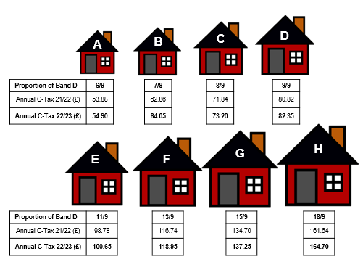

REVENUE RESERVES SUMMARY

Details of the Authority’s General Reserve and each Earmarked Reserve are given below:-
General Reserve - Provides a contingency to cushion the impact of unexpected events or exceptional costs, and in extreme circumstances would be used to provide a working cash balance to cushion the impact of uneven cash flows, and help avoid unnecessary temporary borrowing. For example, the General Reserve could be used to fund any unforeseen loss on the Authority’s share of Kent District’s and Medway Council’s Business Rate collection funds. Within the 2022/23 Reserve Strategy, it is proposed that the level of General Reserve is set at approximately 5% of the Authority’s base revenue budget. The appropriateness of this level is assessed on an annual basis, through a detailed risk assessment.
Earmarked Reserves - Sums specifically set aside not only provide funds to meet future known or predicted expenditure or liabilities, but also support the transformation of the service to ensure it is fit for the future. Earmarked Reserves are typically used to smooth the impact on the revenue budget (and Council Tax) of expenditure that would otherwise cause significant fluctuations in the annual budget requirement, such as expenditure on the replacement of vehicles and equipment. Earmarked Reserves are also of use where there may be plans to introduce a policy change or a service improvement which initially requires a one-off increase in expenditure for which additional resources are required, or where there is a future budget liability or pressure which is known, but for which the timing of payments or change in funding is uncertain. The purpose of each reserve is clearly defined, with regular reviews to ensure continued relevance and adequacy.
- Government Grants - Used to carry forward unspent Government grants.

- Infrastructure - Used to fund revenue and capital investment in infrastructure assets (premises, IT, vehicles and operational equipment) and reflects funding for a significant programme of investment in these areas over the medium-term.

- Insurance and Resource - Used to smooth the impact of insurance claims volatility between financial years. The reserve will also be used to support significant one-off costs that may arise, for example for higher levels of pay awards, compared to that planned for in the MTFP, or as we are seeing now, significant increases in inflation in some areas of supplies, which again may arise after the budget is agreed. An element of this reserve will be used to temporarily balance the revenue budget, which will help support the timing differences between spending requirements, funding and income sources and the delivery of base savings.

- Rolling Budget - Used to fund committed expenditure where the goods or services will not be received or delivered until the following financial year.

- Service Transformation and Productivity - Used as a one-off funding resource to help pump-prime new transformation initiatives or improvements to the Service which may arise in-year or be planned for future years, as set out in the relevant Strategies. It will also be used to help support collaborative initiatives with other blue light services and partner agencies, and fund a number of fundamental reviews across the Service which will help ensure that it stays fit for the future.
REVENUE AND CAPITAL RESERVES SUMMARY
The Table below shows the forecast closing revenue reserve balances along with the estimated closing capital receipts balances for the years 2021/22 to 2025/26. Figures exclude any transfer to reserves that may be required at year end as a result of the forecast underspend on the 2021/22 revenue budget. Also excluded from these figures is the 2021/22 transfer to the Government Grants reserve (and corresponding drawdown in 2022/23) in relation to the funding for the additional business rates reliefs announced by the Governement after budgets were set for 2021/22 (estimated at £1.529m).
General and Earmarked Reserves - Forecast Balances  (All figures are £’000) | 31/03/22  Forecast Balance | 31/03/23  Forecast Balance | 31/03/24  Forecast Balance | 31/03/25  Forecast Balance | 31/03/26  Forecast Balance
General Reserve | 3,760 | 3,970 | 3,990 | 4,120 | 4,230
Earmarked Reserves:
Government Grants | 1,575 | 1,090 | 0 | 0 | 0
Infrastructure | 25,618 | 17,784 | 6,116 | 2,923 | 1,097
Insurance and Resource | 2,841 | 2,415 | 2,415 | 2,415 | 2,415
Rolling Budgets | 278 | 117 | 15 | 0 | 0
Service Transformation & Productivity | 257 | 14 | 0 | 0 | 0
Total Earmarked Reserves | 30,569 | 21,420 | 8,546 | 5,338 | 3,512
Total General and Earmarked Reserves | 34,329 | 25,390 | 12,536 | 9,458 | 7,742
Capital Receipts Reserve | 9,449 | 4,185 | 1,485 | 0 | 0
Total Reserves | 43,778 | 29,575 | 14,021 | 9,458 | 7,742
Net Change in Total Reserves | (6,028) | (14,203) | (15,554) | (4,563) | (1,716)

Breakdown of forecast Government Grant balance as at 31.03.2022 (excluding transfer to the reserve in relation to the funding for additional Business Rates reliefs (est. £1.529m)):-
Grant: | £’000
National Resilience (New Dimensions) Grant | 113
New Risks Grant | 213
Grenfell Infrastructure Grant | 87
Protection Uplift Grant | 205
Protection Accreditation Grant | 45
Emergency Services Mobile Communications Programme Grant | 347
Pensions Administration Grant – McCloud Remedy | 97
Local Tax Income Guarantee Scheme Grant | 468
Estimated Total Government Grants Remaining at 31.03.2022 | 1,575
MEDIUM TERM FINANCIAL PLAN 2022/23 – 2025/26

Revenue Budget Assumptions (Funding, Pressures and Savings)

The revenue budget funding for 2022/23 to 2025/26 is estimated using various assumptions, as much of the information required to set the medium term budget is not yet known. As detailed previously, the Government has only confirmed funding for 2022/23 and intends to conduct a Fair Funding Review which may impact on future funding from 2023/24. On that basis a prudent approach has been taken in estimating funding that may be received from central Government in future years. Details of the main assumptions used in estimating the revenue budgets for 2023/24 to 2025/26 are detailed below:-
Funding assumptions at this point in time are:-
- The Settlement Funding Assessment (Revenue Support Grant, Baseline Business Rates and Top-up Grant) will increase in line with inflation (at the Government target rate of 2%) per year.
- The one-off Services Grant (£1.027m for 2022/23) will be replaced with a lower value grant from 2023/24, estimated at £355k, to fund only the national insurance increase (Social Care Levy).
- A prudent estimate that the Council Tax base will increase by 1.5% in 2023/24 and 2024/25 and 1.0% in 2025/26.
- The Council Tax charge will increase by just under 2% per year (in line with the current referendum principles).
- Apart from the deficit related to 2020/21 (where the balance is to be spread over 2022/23 and 2023/24) there will be no surplus or deficit on the Collection Funds in later years.
Once further clarity is available on the level of funding available in future years, the scale of the savings that the Authority needs to make may change.
Anticipated Budget Pressures:
(All figures are £’000) | 2023/24 |  | 2024/25 | 2025/26
 | Budget |  | Budget | Budget
Full year impact of est. 3% pay award in 2022/23 (Grey Book) | 324 |  | 0 | 0
2% pay award for all staff groups in each year | 1,008 |  | 1,030 | 1,049
Full year impact of est. 2% pay award in prior year (Grey Book) |  | 0 | 227 | 232
Corporate staff increments | 245 |  | 123 | 126
Bank holiday pay adjustment | 0 |  | 0 | 50
Actuarial valuation - LGPS | 456 |  | 0 | 0
Actuarial valuation - FPS | 0 |  | 916 | 0
Ill health pensions (2 new ill health retirements each year) | 0 |  | 0 | 34
Annual inflation each year | 382 |  | 367 | 388
Pressures identified from spending plan review | 198 |  | 125 | 26
Other pressures | 4 |  | 5 | 3
Total Pressures | 2,617 |  | 2,793 | 1,908
MEDIUM TERM FINANCIAL PLAN 2022/23 – 2025/26

Anticipated Budget Savings:
(All figures are £’000) | 2023/24 | 2024/25 | 2025/26
 | Budget | Budget | Budget
Temporary posts deleted from budget | -445 | -56 | 0
Bank holiday pay adjustment | 0 | -94 | 0
Ill health pensions (2 new ill health retirements each year) | -67 | -61 | 0
Price increases not given to areas of discretionary spend | -229 | -233 | -250
Savings identified from spending plan review | -349 | -39 | -513
Total Savings | -1,090 | -483 | -763
Other Budget Adjustments - The MTFP is currently showing that £1.081m of unidentified base budget savings are required to balance the budget in 2023/24 but that projected funding levels in 2024/25 and 2025/26 exceed the base budget requirement by £241k and £1.085m respectively. As funding levels beyond 2022/23 are uncertain the timing and amounts may change as and when future funding levels are confirmed.

Summary Revenue Budget Estimates
The Table below summarises the base budget changes in each of the financial years between 2022/23 and 2025/26. Also shown is a breakdown of funding sources and additional information with regards to increases in Council Tax receipts for the same years:-
(All figures are £’000) | 2022/23 | 2023/24 | 2024/25 | 2025/26
 | Budget | Budget | Budget | Budget
Base Budget brought forward | 74,849 | 79,408 | 79,854 | 82,405
Pay, Pensions, Prices and Pressures | 6,328 | 2,617 | 2,793 | 1,908
Savings | -1,769 | -1,090 | -483 | -763
Other Budget Adjustments (see note above) | 0 | -1,081 | 241 | 1,085
Base Budget carried forward | 79,408 | 79,854 | 82,405 | 84,635
Transfers from Earmarked Reserves – see page 3 | -2,189 | -234 | 0 | 0
Transfer to General Reserve | 210 | 20 | 130 | 110
Net Revenue Budget | 77,429 | 79,640 | 82,535 | 84,745
Net change £ | 5,856 | 2,217 | 2,895 | 2,210
Net change % | +8.18% | +2.86% | +3.63% | +2.68%
Budget funded by:-
Council Tax | 53,637 | 55,512 | 57,432 | 59,166
Services Grant | 1,027 | 355 | 355 | 355
Revenue Support Grant | 6,655 | 6,788 | 6,924 | 7,062
Business Rates Baseline/Growth | 6,047 | 6,517 | 6,647 | 6,780
Top-up Grant | 8,514 | 8,684 | 8,858 | 9,035
Net Deficit on Collection Funds | -1,207 | -507 | 0 | 0
Section 31 Business Rates Grant | 2,756 | 2,291 | 2,319 | 2,347
Total Funding | 77,429 | 79,640 | 82,535 | 84,745
MEDIUM TERM FINANCIAL PLAN 2022/23 – 2025/26

Analysis of Additional Council Tax Income

 | 2022/23  Actual | 2023/24  Estimate | 2024/25  Estimate | 2025/26  Estimate
Council Tax Base | 651,326 | 661,096 | 671,013 | 677,723
Council Tax Base Growth % | 2.42% | 1.50% | 1.50% | 1.00%
Council Tax Base Growth £’000 | 1,242 | 805 | 833 | 574
Council Tax Band D Charge £ | 82.35 | 83.97 | 85.59 | 87.30
Council Tax Band D Charge Increase % | 1.89% | 1.97% | 1.93% | 1.99%
Council Tax Band D Charge Increase £ | 1.53 | 1.62 | 1.62 | 1.71
Council Tax Charge Increase £’000 | 997 | 1,070 | 1,087 | 1,160
Additional Income from Council Tax £’000 | 2,239 | 1,875 | 1,920 | 1,734

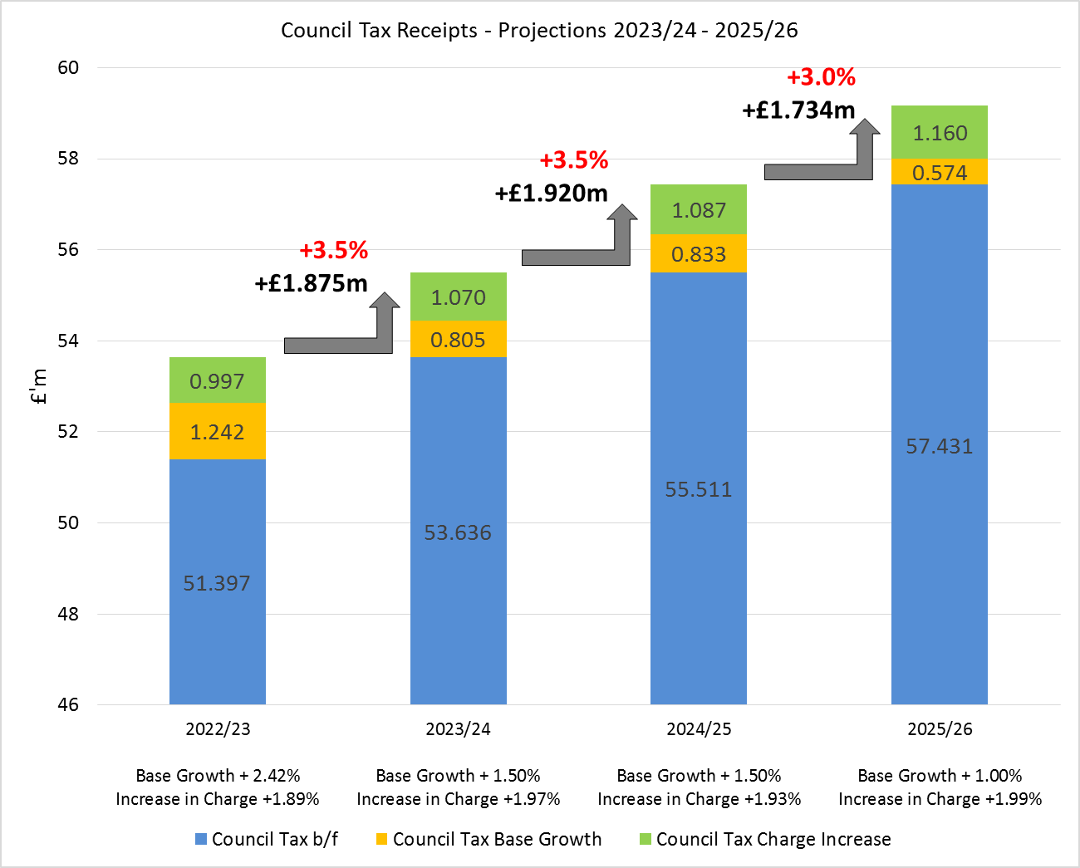
MEDIUM TERM INFRASTRUCTURE PLAN 2022/23 - 2025/26

Medium Term Infrastructure Plan – Capital and Revenue

Capital Expenditure Plan
The Capital Plan has been developed in line with the proposals detailed in the Customer Safety Plan and Corporate Strategies, to support and maintain the key assets and infrastructure across the organisation. The main areas contained within the Plan are detailed below:-
Building works - We aim to deliver a programme of refurbishment and improvement to all of our estate, of over 80 properties, to not only ensure that the Service and its operational bases remain fit for the future but also to improve efficiency to enable us to achieve carbon neutrality by 2030. Current reviews are considering our options for the Maidstone site and also a possible reconfiguration of the Road Safety Building at Rochester. Indicative funding requirements have been incorporated into the capital programme, to ensure that any redevelopments can be afforded. Redevelopment of the Ashford site, including the Live Fire facilities, is underway and it is expected that this major work will be completed towards the end of 2023/24.

Vehicle replacements - There is a comprehensive long-term programme in place for the replacement of the operational fleet of fire engines, specialist vehicles, pool and response cars. The fleet is reviewed on a regular basis to determine any change in the numbers and types of vehicles that may be needed to facilitate operational capability identified in the Customer Safety Plan. In 2019/20 the Service undertook its first acquisition of dual fuel vehicles and will soon take delivery of 36 self-charging hybrid vehicles. We will continue to consider, where appropriate to do so, more eco-friendly products as they become available.

Mobile Data Terminals - This is an operational response I.T project to install data terminals in all fire engines and response vehicles as well as Satnavs and tracking devices and is due to be completed during 2022/23.
Revenue Expenditure Plan
One-off expenditure in relation to premises, IT and operational equipment that does not meet the criteria for capitalisation is funded from the Infrastructure Revenue Plan.
Premises - The Plan contains proposals for improvements across the estate and for works to relocate our Control Room. There is also funding for climate works, security upgrade and fire compartmentation works.
IT - There is significant investment planned for IT as detailed in the IT investment programme. This includes; expenditure on key back office systems such as Workforce Planning and asset management; expenditure on responsive operational systems such as ESN, Command and Control and Fireground Radios; expenditure on systems that underpin the pro-active work of the organisation such as Operational Response (CRM); plus expenditure on underlying core IT infrastructure such as replacement desktop and mobile equipment.
Equipment – There are plans to upgrade various items of operational equipment and the vehicle CCTV/Telematics in the near future.
MEDIUM TERM INFRASTRUCTURE PLAN 2022/23 – 2025/26
Medium Term Infrastructure Plan - Expenditure

The Tables below details the capital and revenue infrastructure spend provisionally planned between 2022/23 and 2025/26:-

Capital Infrastructure Programme

(All figures are £’000) |  | 2022/23 | 2023/24 | 2024/25 | 2025/26 | 2022-26
 |  | Budget | Budget | Budget | Budget | Total
Future Station Development |  | 4,660 | 8,830 | 1,250 | 1,000 | 15,740
Total Station Development |  | 4,660 | 8,830 | 1,250 | 1,000 | 15,740
Roofing Works |  | 100 | 250 | 300 | 100 | 750
Boilers |  | 122 | 703 | 431 | 388 | 1,644
Generator |  | 50 | 20 | 20 | 20 | 110
Total Premises |  | 272 | 973 | 751 | 508 | 2,504
Operational Response Project |  | 285 | 0 | 530 | 0 | 815
Total Systems |  | 285 | 0 | 530 | 0 | 815
Pumps |  | 1,545 | 220 | 0 | 0 | 1,765
Rescue Pumps |  | 3,163 | 3,163 | 4,102 | 4,538 | 14,966
Light Fleet |  | 2,285 | 42 | 0 | 0 | 2,327
Specialist Vehicles |  | 981 | 1,454 | 645 | 473 | 3,553
Total Vehicles & Appliances |  | 7,974 | 4,879 | 4,747 | 5,011 | 22,611
Total Capital Expenditure |  | 13,191 | 14,682 | 7,278 | 6,519 | 41,670
* A ten-year capital programme is detailed in the Capital Strategy
Revenue Infrastructure Programme

(All figures are £’000) |  | 2022/23  Budget | 2023/24  Budget | 2024/25  Budget | 2025/26  Budget | 2022-26  Total
Premises |  | 1,343 | 232 | 68 | 28 | 1,671
IT |  | 3,439 | 3,128 | 1,216 | 2,016 | 9,799
Vehicles and Equipment |  | 685 | 424 | 106 | 56 | 1,271
Total Revenue Expenditure |  | 5,467 | 3,784 | 1,390 | 2,100 | 12,741
Total Revenue and Capital |  | 18,658 | 18,466 | 8,668 | 8,619 | 54,411

MEDIUM TERM INFRASTRUCTURE PLAN 2022/23 – 2025/26
Medium Term Infrastructure Plan - Expenditure

The Chart below details the capital and revenue infrastructure spend provisionally planned between 2022/23 and 2025/26:-

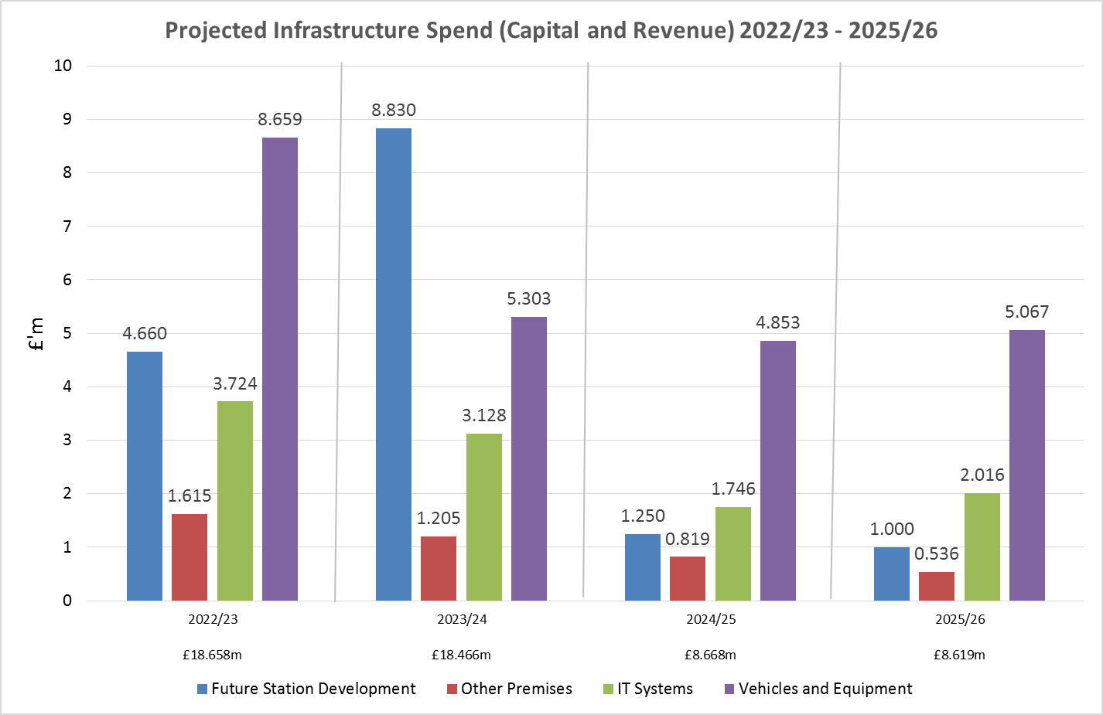

MEDIUM TERM INFRASTRUCTURE PLAN 2022/23 – 2025/26

Infrastructure Plan - Funding and Reserve Balances

The Infrastructure Plan is funded from various sources, each described below:-
Revenue Contributions / Reserves - The base revenue budget has a level of funding which may be used to support the funding of both the revenue and capital infrastructure plans. The Authority also has revenue resources set aside in the Infrastructure Reserve which can be used to fund revenue and capital investment in infrastructure assets to ensure continuous development and improvement across the organisation.
Capital Receipts - The use of capital receipts from the disposal of assets is governed by Regulations and can only be used to fund capital expenditure and repay debt. Where properties are identified as surplus to operational requirements, Members approval is sought for their disposal. Cash receipts which are generated from the asset disposal and which are in excess of £10k, must be used to support new capital investment or offset future debt or transitional costs. They cannot be used to fund day to day revenue expenditure. As at 31 March 2022 there are forecast to be unapplied capital receipts arising from the disposal of a number of the Authority’s assets, including redundant fire stations, land and unoccupied housing of £9.449m.
Prudential Borrowing - The Authority can use prudential borrowing to fund capital expenditure provided that such borrowing is affordable, prudent and sustainable over the medium term. A range of calculations (prudential indicators) are completed as part of the annual budget setting process to evidence this. These make sure that the cost of paying for interest charges and the repayment of principal is taken into account when developing the Medium Term Financial Plan.

MEDIUM TERM INFRASTRUCTURE PLAN 2022/23 – 2025/26
Infrastructure Plan - Funding and Reserve Balances
The Tables below show the funding sources for the capital plan plus anticipated balances on the capital receipts and infrastructure reserves for 2022/23 to 2025/26.
Capital Infrastructure Plan Funding
(All figures are £’000) |  | 2022/23  Budget |  | 2023/24  Budget |  | 2024/25  Budget |  | 2025/26  Budget | 2022-26  Total
Funded By:
Revenue Contributions - from Base Budget |  | 2,592 |  | 2,592 |  | 2,592 |  | 2,592 | 10,368
Revenue Contributions – from Reserve |  | 3,699 |  | 9,390 |  | 3,002 |  | 927 | 17,018
Prudential Borrowing |  | 0 |  | 0 |  | 0 |  | 3,000 | 3,000
Capital Receipts Applied |  | 6,900 |  | 2,700 |  | 1,684 |  | 0 | 11,284
Total Funding |  | 13,191 |  | 14,682 |  | 7,278 |  | 6,519 | 41,670
Revenue Infrastructure Plan Funding
(All figures are £’000) |  | 2022/23  Budget |  | 2023/24  Budget |  | 2024/25  Budget |  | 2025/26  Budget | 2022-26  Total
Funded By:
Revenue Contributions - from Base Budget |  | 1,200 |  | 1,200 |  | 1,200 |  | 1,200 | 4,800
Revenue Contributions – from Reserve |  | 4,135 |  | 2,278 |  | 190 |  | 900 | 7,503
One off funding |  | 10 |  | 50 |  | 0 |  | 0 | 60
ESMCP (ESN) Grant |  | 122 |  | 256 |  | 0 |  | 0 | 378
Total Funding |  | 5,467 |  | 3,784 |  | 1,390 |  | 2,100 | 12,741

Capital Receipts Reserve
(All figures are £’000) | Forecast  31.3.22 | Forecast  31.3.23 |  | Forecast  31.3.24 |  | Forecast  31.3.25 |  | Forecast  31.3.26
Balance at end of year | 9,449 | 4,185 |  | 1,485 |  | 0 |  | 0

Infrastructure Reserve

(All figures are £’000) | 2022/23  Forecast | 2023/24  Forecast | 2024/25  Forecast | 2025/26  Forecast
Balance at start of year (1 April) | 25,618 | 17,784 | 6,116 | 2,924
Infrastructure reserve – capital movements | -3,699 | -9,390 | -3,002 | -927
Infrastructure reserve - revenue movements | -4,135 | -2,278 | -190 | -900
Balance at end of year (31 March) | 17,784 | 6,116 | 2,924 | 1,097

