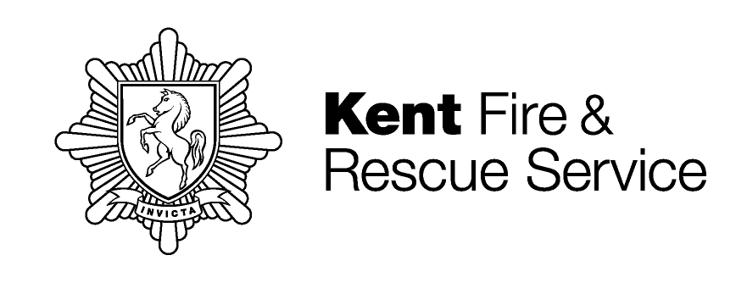

KFRS Home Safety referral form

This form can be used by any agency to refer a person(s) to Kent Fire & Rescue Service where a risk of fire in the home has been identified. KFRS will attempt to undertake a visit for all cases referred. Fields marked * are mandatory.

Personal details of client being referred
Name*: | Tel no*:
Address*:

Postcode*: | Email:
Date of birth*: | SWIFT/ID number:
Has the person(s) consented to the referral including the sharing of information via this form?* Yes/No

Personal details of 3rd party
Name: | Tel no:
Please states the relationship of the 3rd party contact:

Please indicate if we need to contact the third party to arrange the visit? Yes/No

Reason for referral *
Is the referral urgent? Yes/No | If yes, please tell us the reason

Are there any other agencies involved with customer?

Are there any known risks to a lone KFRS worker*? Yes/No | If yes, please provide details

Contact details for referring agency
Name of agency*: | Responsible person/case worker:
Address:

Email*: | Telephone number*:
Date of referral*: | Is feedback required? Yes/No
Your reference for this referral*:

Return this form to:
Kent Fire & Rescue Service, The Godlands, Straw Mill Hill, Tovil, Maidstone, Kent ME15 6XB
Telephone: 0800 923 7000 Email: home@kent.fire-uk.org or securely to; DMHRC.fire-kent@nhs.net

