Kent and Medway Fire and Rescue Authority

Budget Book
And
Medium Term Financial Plan
2023/24 – 2026/27

This Budget Book details the assumptions used by the Authority for developing the 2023/24 budget, the estimates used for later years and explains the proposals contained within the Medium Term Financial Plan.

Budget estimates reflect the projected costs to deliver the initiatives contained within the Customer Safety Plan, the supporting corporate strategies and the updated day-to-day spending plans of each department.

Contents
THE BUDGET STRATEGY 2023/24 - Foreword 1
BUILDING THE 2023/24 REVENUE BUDGET 2 - 11
Revenue Budget Changes 2022/23 to 2023/24 2 - 3
2023/24 Pressures Summary 4 - 5
2023/24 Savings Summary 6
2023/24 Subjective and Functional Budget Presentation 7 - 8
2023/24 Additional Subjective Analysis - Employee Pay Budgets ..9 - 10
2023/24 Additional Subjective Analysis - Reserve Transfers and Income ………………..11
FUNDING THE 2023/24 REVENUE BUDGET 12 - 16
2023/24 Grant Funded Expenditure………………………………………………...…………12
2023/24 Sources of Funding the Net Revenue Budget 13 - 14
Council Tax and Business Rates Income – Additional Information 15 - 16
REVENUE RESERVES SUMMARY 17 - 18
MEDIUM TERM FINANCIAL PLAN 2023/24 – 2026/27 ……………………………………... 19 - 21
Revenue Budget Assumptions (Funding, Pressures and Savings) ………………… 19 - 20
Summary Revenue Budget Estimates …………………………………………………..……20
Analysis of Additional Council Tax Income……………………………………………………21
MEDIUM TERM INFRASTRUCTURE PLAN 2023/24 - 2026/27 ……………………………. 22 - 26
Medium Term Infrastructure Plan ………………………………………………………. 22 - 24
Infrastructure Plan Funding and Reserve Balances ………………………………….. 25 - 26
WHAT DO YOU GET FOR YOUR MONEY? ……………………………………………………….. 27

THE BUDGET STRATEGY 2023/24 - Foreword
The Purpose of the Budget Strategy

The Authority’s budget supports the delivery of the initiatives detailed in the Customer Safety Plan and supporting corporate strategies. When determining spending proposals and Council Tax increases, due consideration is taken of all potential cost pressures and possible savings alongside anticipated funding changes over the medium-term.

- Using the latest technology to engage with customers through targeted campaigns.
- Improve the safety of buildings through targeted auditing and consultation.
- Develop road safety, water safety and arson prevention services with partners.

- Continuing to refine and improve rostering models allowing us to resource in a flexible way to meet changes in the demands of our customers.
- Regularly examining the processes we apply in our day-to-day work and streamlining wherever possible to give a better outcome for our customers.
- Construct a new live fire training facility with LGP/carbonaceous training rig.
- Improve the energy efficiency of our buildings.
- Use technology to better manage, and make more efficient use of, our fleet.
- Deliver a better way of managing servicing for our vehicles.

Productivity and Efficiency
Building Safety and Customer Safety

Infrastructure Investment
Funding the 2023/24 Budget
Examples of Key Themes in the Budget Strategy
On 17 November 2022 the Chancellor presented the Autumn Statement to Parliament and although there were no specific references to Fire and Rescue Services, it was confirmed that there would be no cuts to the funding announced in the Spending Review 2021. The Provisional Local Government Finance Settlement, announced on 19 December 2022, only confirmed funding figures for the Authority for the financial year 2023/24 (with some guiding principles provided for 2024/25). Therefore, government funding levels beyond 2024/25 remain highly uncertain, so planning must be sufficiently flexible to be able to respond to potential future funding changes accordingly.
The provisional settlement confirmed that the 2023 Business Rates revaluation will be implemented in 2023/24 and that the Business Rates multiplier will again be frozen. Implementation of the Business Rates revaluation will increase funding by £592k and the Government will continue to compensate the Authority for the under-indexation of the Business Rates multiplier, meaning the Section 31 grant will increase by £1.186m. Revenue Support Grant will be uplifted by the September 2022 Consumer Price Index providing a funding increase of £675k. The Authority’s Services Grant has reduced, as the Government has withdrawn funding that was provided to the Authority for the 1.25% increase to the employer’s national insurance rate, as this increase has now been reversed. The final settlement, published on 6 February 2023, was in line with the provisional settlement, except for the Services Grant which was reduced by £424k and not £449k.
To ensure that medium-term budget proposals are sustainable, and in light of the responses to the Council Tax consultation, it is proposed that Council Tax should be increased by 6.01%, resulting in an annual increase for a Band D property of £4.95 per year, making the Band D Council Tax charge £87.30 for 2023/24.
Ann Millington
Chief Executive

BUILDING THE 2023/24 REVENUE BUDGET

Revenue Budget Changes 2022/23 to 2023/24
The Table below summarises the incremental adjustments made to the 2022/23 base revenue budget in order to determine the net revenue budget requirement for 2023/24:-
 | £’000 | £’000
Base budget brought forward from 2022/23 |  | 79,408
Pay and pensions related cost pressures (see page 4)
Pay growth (pay awards, pay increments and new posts) | 4,795
Local Government Pension Scheme employer rate increase | 157
Total pay and pensions related cost pressures for 2023/24 |  | 4,952
Non-pay pressures (see page 5)
Inflationary price increases | 1,056
New borrowing costs | 448
Other identified pressures | 2,989
Total non-pay pressures for 2023/24 |  | 4,493
Savings (see page 6)
Pay savings | -1,668
Discretional price increase removal | -629
Other non-pay savings | -1,320
Total savings for 2023/24 |  | -3,617
2023/24 base revenue budget |  | 85,236
Reserve funding adjustments (see page 3)
Transfer from Earmarked Reserves - Local Tax Income Guarantee | -234
Transfer to General Reserve | 290
Total reserve funding adjustments in 2023/24 |  | 56
Net revenue budget requirement for 2023/24 |  | 85,292

BUILDING THE 2023/24 REVENUE BUDGET

Revenue Budget Changes 2022/23 to 2023/24

Reserve Funding Adjustments – Additional Explanations

An explanation detailing the reason for each of the reserve adjustments listed on the previous page is provided below:

Transfer from Earmarked Reserves – Local Tax Income Guarantee – The Government has provided the Authority with grant funding to cover 75% of the irrecoverable Covid-19 related losses on the 2020/21 Collection Funds. These losses are spread in Medway and Kent District Councils Collection Funds over the three financial years 2021/22, 2022/23 and 2023/24. The government grant funding has therefore been put into an Earmarked Reserve and will be released from the reserve to coincide with the recovery of the Collection Fund deficits by Medway and Kent District Councils. Therefore, the remaining balance of £234k is to be released from the reserve in 2023/24.

Transfer to General Reserve – The amount to be transferred to the General Reserve in 2023/24 is £290k, increasing the balance of the reserve to £4.260m for 2023/24. This will ensure that the General Reserve balance is maintained at approximately 5% of the base revenue budget, as set out in the 2023/24 Reserves Strategy.

BUILDING THE 2023/24 REVENUE BUDGET

2023/24 Pressures Summary

Pay and Pensions Related Cost Pressures
The Authority uses an incremental approach to develop the budget, so the 2022/23 base revenue budget has been adjusted to reflect the pressures identified below:-
Pay and Pensions Related Costs Pressures | £’000
Pay Awards for 2022/23  It was assumed that the nationally agreed pay awards for 2022/23 would be 3% for all staff groups. Subsequently, a flat increase of £1,925 was agreed for ‘green book’ support staff (avg. of just over 5%) and whilst an offer of 5% has been made to operational staff this has not yet been agreed. It has been assumed that the pay budget will need to be increased to reflect a 5% increase for operational staff for 2022/23. This figure also includes increasing the budget for the full year impact of the 2022/23 pay award for operational staff (as the pay award is effective from 1st July). | 1,703
Pay Awards for 2023/24  It has been assumed that the nationally agreed pay awards for 2023/24 will be 2% for all staff groups. A full year impact has been assumed for ‘green book’ staff and principle officers, whilst it is assumed that the operational staff pay award will continue to be applied from the 1st July. | 1,167
Staff Increments  Staff on green book terms and conditions will generally receive an annual incremental pay scale increase until they reach the top of the pay grade for the job role. | 218
Restructures and Other Pay Pressures  Various restructures and new posts have been agreed for Response and Resilience, Building Safety, Fleet and HR. In many cases these changes have been implemented to keep up with changing demands and to ensure that the service remains fit for the future. The main items are £500k for additional cover at wholetime Fire Stations, £388k for the introduction of a new Home Fire Safety Visit Taskforce (11), £275k for new Building Safety Enforcement and Inspector posts (7), £110k for changes to the Day Crewed allowance and £88k for changes to the wholetime trainee pathway. | 1,677
Apprenticeship Scheme Levy  The apprenticeship levy is calculated as a percentage of pay so the budget has been increased in line with the revised pay budget. | 9
Actuarial Valuations  As a result of the most recent Local Government Pension Scheme (LGPS) actuarial valuation the employer contribution rate will increase by 1% (to 16.5%) on 1st April 2023. | 157
Pensions – Ill Health and Injury Liabilities  The budget provides for 2 ill health retirements in 2023/24, as well as an increase to the cost of an inflationary uplift to annual injury pensions. As contributions to the Pension Fund for ill health retirements are made over 3 years the profile of ill health retirements will result in an increase or decrease in the base budget requirement each year. |  | 21
Total Pay and Pension Related Cost Pressures for 2023/24 |  | 4,952

BUILDING THE 2023/24 REVENUE BUDGET

2023/24 Pressures Summary
Non-pay Pressures
Non-Pay Pressures | £’000
Prices  An inflationary increase has been allocated to those budgets that have contracts which commit the Authority to pay an uplifted amount for 2023/24. An increase has also been provided to budgets where there is an unavoidable increase in costs, such as an increase in Home Office charges for accessing the Airwave secure emergency communication system. For other areas of discretionary spend, where price increases will be contained within existing budget allocations, there is a corresponding saving (see page 6). | 1,056
New Borrowing Costs  The Minimum Revenue Provision has increased in 2023/24 due to internal borrowing to fund planned capital expenditure on the Ashford Fire Station and Live Fire Training facility and the lease of premises to deliver vehicle servicing and maintenance in house from 1st April 2023. | 448
Other Pressures  Temporary posts and one-off funding required for the implementation of initiatives contained within the corporate strategies has increased the Service Transformation and Productivity reserve requirement by £882k, so additional funding has been allocated to the reserve for this purpose. The programme of premises works has been reviewed and updated along with the facilities budgets resulting in a base budget pressure of £548k. IT software, subscriptions and licences have increased, along with the phasing out of the Firelink grant (government contribution towards Airwave costs), which has resulted in a pressure of £427k. Fleet servicing and maintenance will be brought back in house from 1st April, so non-pay base budgets have been increased by £101k. Whenever opportunities arise, the service is keen to explore options for innovation and improvements to the frontline working environment, as such an additional £300k has been set aside to be able to resource such opportunities to our best advantage. Budget increases have also been needed for vehicle fuel (+£265k), operational equipment (+£230k), the external audit fee (+£83k) and, subscriptions to the Institute of Fire Engineers (IFE) and LinkedIn Learning (+£83k) in 2023/24. Other minor budget increases total £70k. | 2,989
Total Non-Pay Pressures for 2023/24 | 4,493
Total Pressures for 2023/24 | 9,445

BUILDING THE 2023/24 REVENUE BUDGET

2023/24 Savings Summary
The Authority uses an incremental approach to develop the budget, so the 2022/23 base revenue budget has been adjusted to reflect the savings identified below:-
Pay Savings | £’000
Temporary Posts Adjustment  The number of temporary positions funded from base budget (such as maternity cover etc.) has reduced for 2023/24. | -561
On-call Pay Savings  The on-call pay budget has been reduced as a result of the implementation of the whole-time part-time contracts as these new contracts have generated additional savings against the on-call base budget. In addition, on-call activity payments have not increased to the levels anticipated following contractual changes in regards to training and threshold pay, so the budget has been reduced to reflect anticipated costs going forward. | -692
National Insurance Changes  The government has reversed the 1.25% increase in the employer national insurance rate resulting in a saving, but this is offset by a reduction in government grant funding. | -415
Total Pay Savings for 2023/24 | -1,668

Non-pay Savings | £’000
Inflation on Discretionary Spend  Inflationary price increases on areas of discretionary spend, such as stationary, have been removed, where price increases can be contained within existing budget allocations. | -629
Other Savings  This mainly relates to additional investment income (£1.2m) where interest rates have risen considerably since last year. Additionally, base budget savings have been identified from the Managed Print project (£32k), Dynamics Software Licences (£29k), Personal Protective Equipment (PPE) budget (£27k) and, other savings totalling £32k. | -1,320
Total Non-pay Savings for 2023/24 | -1,949
Total Savings for 2023/24 | -3,617

BUILDING THE 2023/24 REVENUE BUDGET

2023/24 Subjective and Functional Budget Presentation
Subjective and Functional Analysis
The Table and Chart below summarise the total net revenue budget of £85.292m for 2023/24 by Subjective and Functional headings:-
(All figures are £’000) | Operational Response and Resilience | Customer Safety, Building Safety, Engagement  & Collaboration | Customer Services | Pensions, Financing and Other Costs | Total  Net Budget
Subjective:
Employee Pay Costs | 52,587 | 7,305 | 10,485 | 0 | 70,377
Other Employee Costs | 16 | 0 | 1,288 | 0 | 1,304
Direct Pension Costs | 0 | 0 | 0 | 2,101 | 2,101
Premises Costs | 302 | 3 | 4,960 | 0 | 5,265
Transport Costs | 2,092 | 5 | 378 | 0 | 2,475
Supplies and Services | 3,154 | 590 | 8,014 | 114 | 11,872
Capital Financing | 0 | 0 | 0 | 3,417 | 3,417
Reserve Transfers | 0 | 0 | 0 | -2,068 | -2,068
Income | -6,782 | -614 | -663 | -1,392 | -9,451
Net Budget for 2023/24 | 51,369 | 7,289 | 24,462 | 2,172 | 85,292
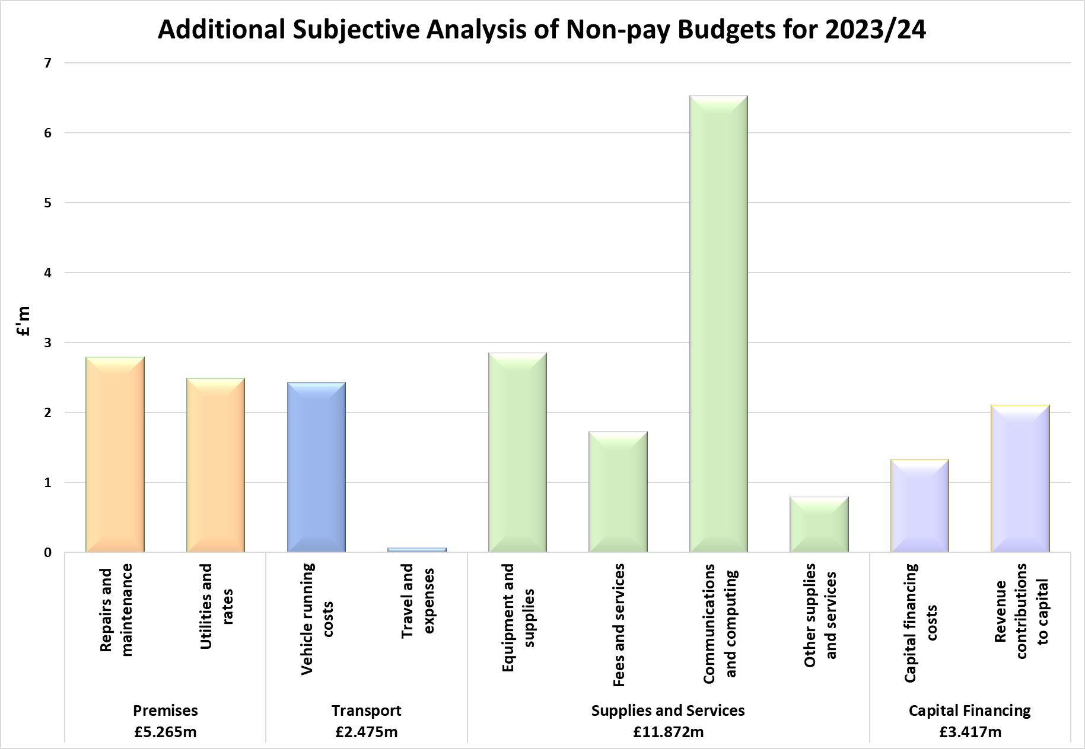

BUILDING THE 2023/24 REVENUE BUDGET

2023/24 Subjective and Functional Budget Presentation
Functional Analysis
The Chart below summarises the total net revenue budget of £85.292m for 2023/24 by Function (in £’000’s) and provides details of the activity areas under each functional heading;
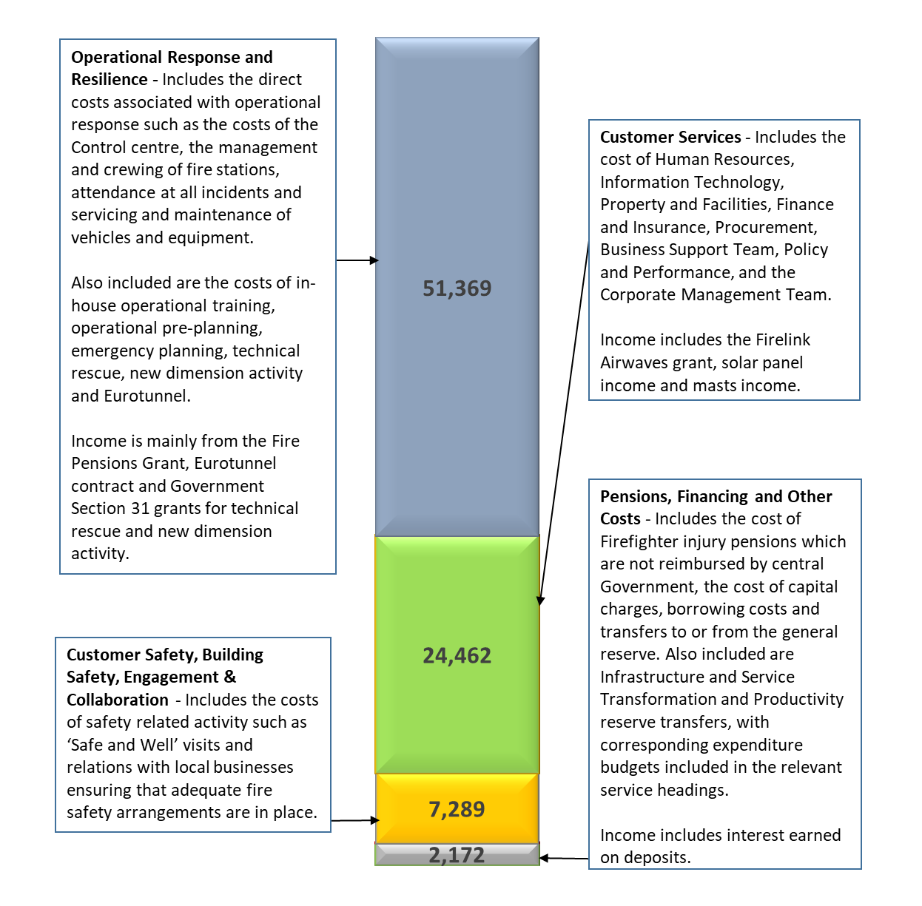
BUILDING THE 2023/24 REVENUE BUDGET

2023/24 Additional Subjective Analysis - Employee Pay Budgets

The budget assumes that pay will increase by 2% in 2023/24. Approximately 82% of the net revenue budget relates to employee pay costs (£70.377m). The budget allocated to each staff group and details of which personnel sit within each staff group is described below (in £’000’s):-

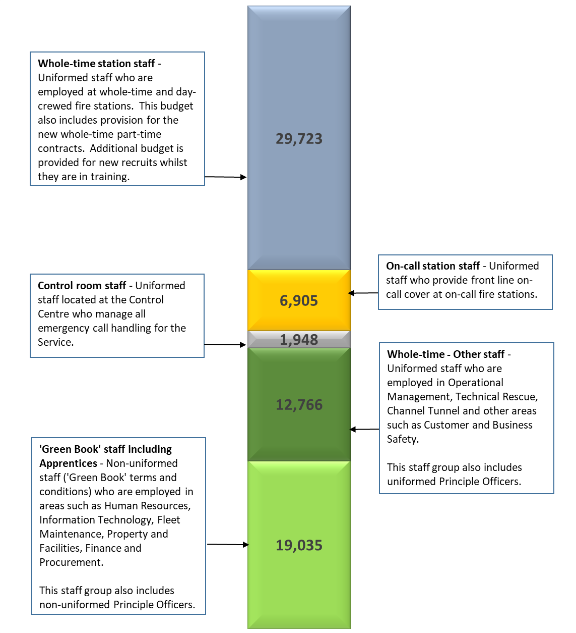
BUILDING THE 2023/24 REVENUE BUDGET

2023/24 Additional Subjective Analysis - Employee Pay Budgets
The Chart below shows the 2023/24 budget and full time equivalent (FTE) for each staff group split by pay, national insurance, employer pension contributions and apprenticeship levy:-

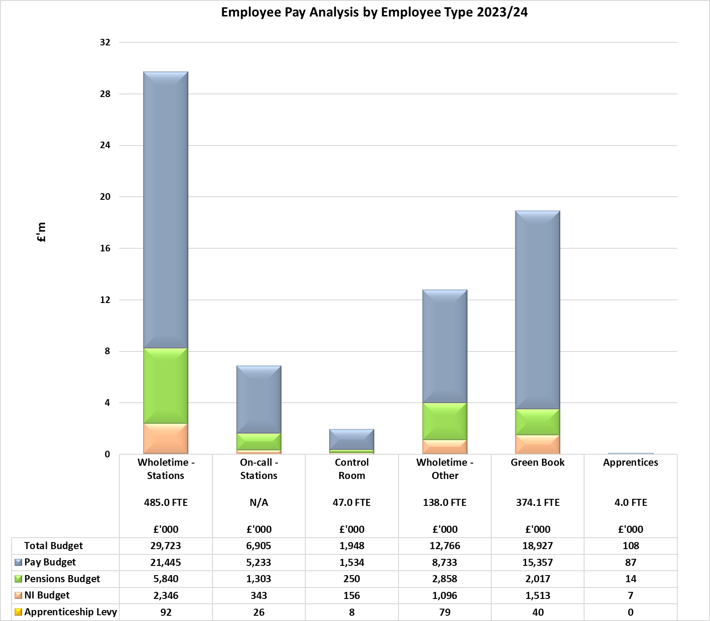

 | Operational Response and Resilience |  | Customer Safety, Building Safety, Engagement & Collaboration |  | Customer Services |  | Total  Pay
Pay Group | FTE | Budget | FTE | Budget | FTE | Budget | FTE | Budget
 |  | £’000 |  | £’000 |  | £’000 |  | £’000
WT - Stations | 485.0 | 29,723 | 0.0 | 0 | 0.0 | 0 | 485.0 | 29,723
On-call - Stations | N/A | 6,905 | 0.0 | 0 | 0.0 | 0 | N/A | 6,905
Control Room | 47.0 | 1,948 | 0.0 | 0 | 0.0 | 0 | 47.0 | 1,948
WT - Other | 109.0* | 10,134 | 20.0 | 1,617 | 9.0 | 1,015 | 138.0* | 12,766
Green Book | 70.1 | 3,877 | 134.4 | 5,688 | 169.6 | 9,362 | 374.1 | 18,927
Apprentices | 0.0 | 0 | 0.0 | 0 | 4.0 | 108 | 4.0 | 108
Total Pay Budget | 711.1* | 52,587 | 154.4 | 7,305 | 182.6 | 10,485 | 1,048.1 | 70,377
* excludes WT trainee recruits
BUILDING THE 2023/24 REVENUE BUDGET

2023/24 Additional Subjective Analysis - Reserve Transfers and Income

The Chart below provides a breakdown of the total £2.068m net reserve transfers included within the net revenue budget of £85.292m for 2023/24 along with details of the type of expenditure funded by the reserve transfer:
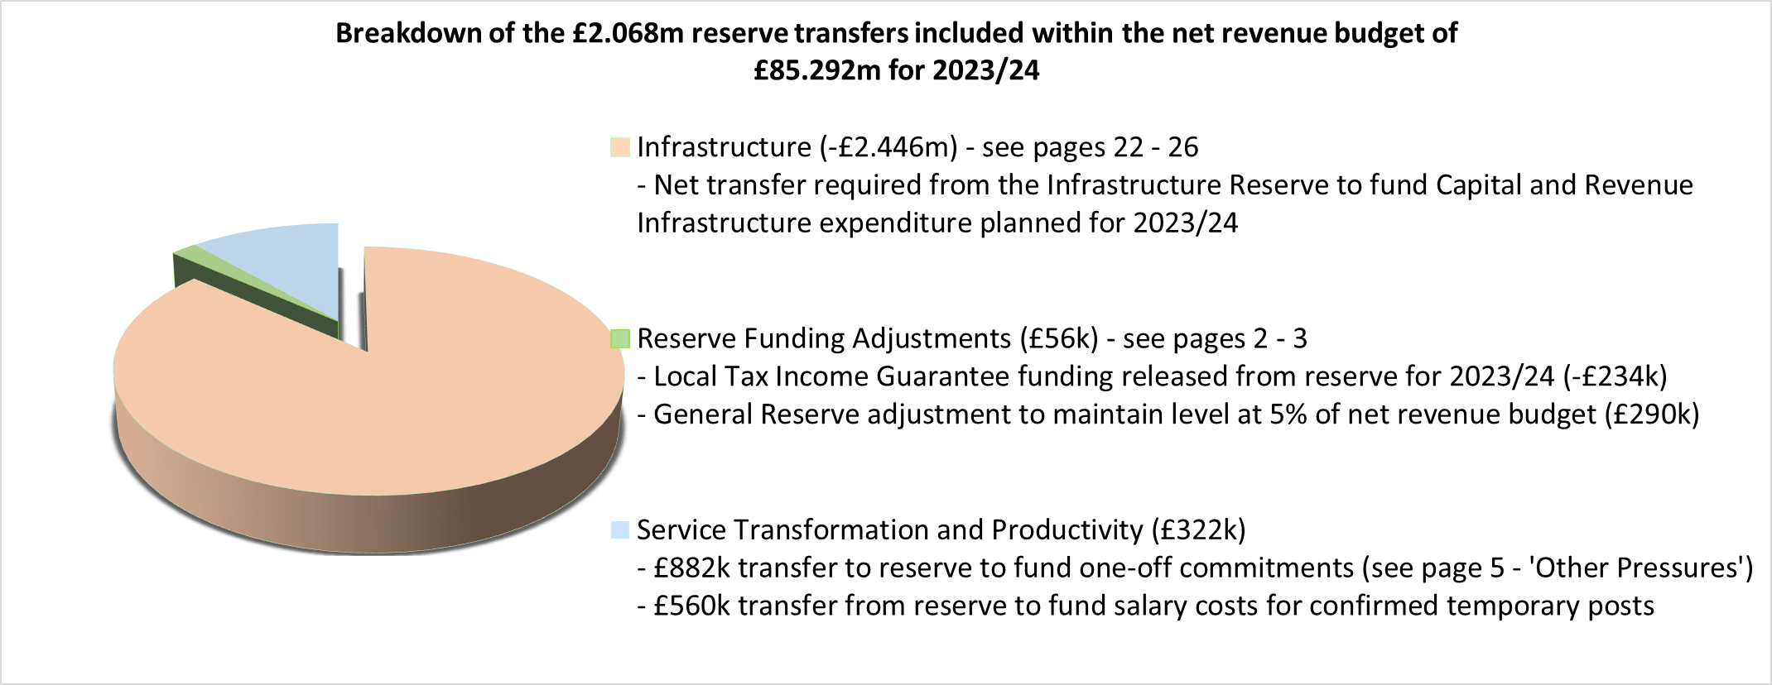

The Chart below provides a breakdown of the total £9.451m income included within the net revenue budget of £85.292m for 2023/24 along with details of the type of expenditure funded by this income:
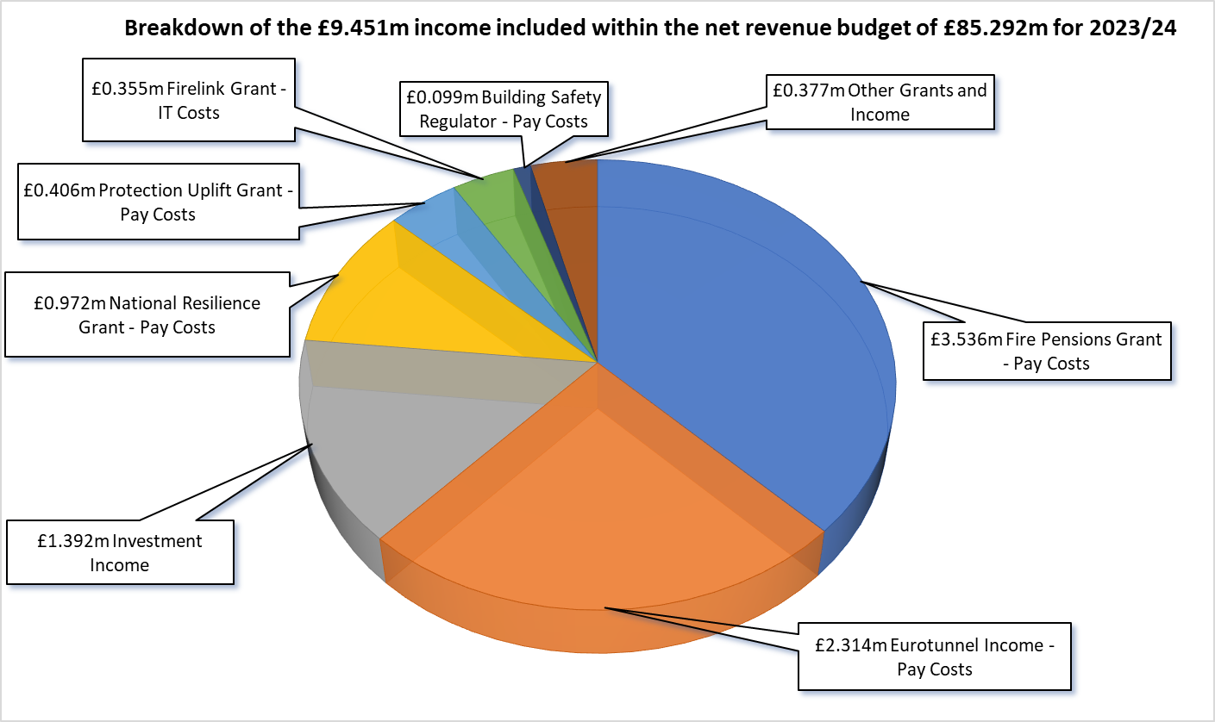

Further details regarding the grant income and related expenditure are provided on page 12.
FUNDING THE 2023/24 REVENUE BUDGET

2023/24 Grant Funded Expenditure

In addition to the non-specific Government grants that form part of the Authority’s overall funding (pages 13 and 14), a proportion of the Authority’s annual expenditure is offset by other Government grant income. These grants are usually provided for specific purposes and will therefore be matched to specific grant-related expenditure. Grant funds may be carried forward within Earmarked Reserves if they are not spent in the year in which they are allocated. Detailed below are the estimated grant allocations for 2023/24:-
 | £’000
Fire Pensions Grant - This grant is provided to cover a proportion of the increase in costs resulting from the significantly higher employer pension contribution rates following the last Firefighters’ Pension Scheme valuation. The amount of grant has been budgeted at the same amount that has been received in previous years. | 3,536
National Resilience (formerly New Dimension) Grant - This grant provides funding towards the cost of various resilience activities including the costs of the Technical Rescue team. The amount of grant has not been confirmed for 2023/24 so the budget has been built on the assumption that the same amount will be received as in 2022/23. | 972
Protection Uplift Grant - This grant provides funding to support fire protection work and to respond to new burdens arising from the Fire Safety Act. The amount of grant has not been confirmed for 2023/24 so the budget has been built on the assumption that the same amount will be received as in 2022/23. | 406
Firelink Grant - This grant partly covers the difference between the annual charge for the Firelink managed service radio scheme and the legacy costs of the now decommissioned radio scheme. Following confirmation of government intentions to phase this grant out over 5 years, this grant has been decreased by a further 20% for 2023/24 on top of the 20% reduction in 2022/23. | 355
Building Safety Regulator Grant - The Building Safety Act (2022) places new requirements on FRAs in working closely with the new Building Safety Regulator, which will regulate higher-risk buildings. One-off new burdens funding has been agreed to recruit and train two Inspecting Officers. The amount of grant budgeted is based on the recovery of costs expected to be incurred in 2023/24. | 99

FUNDING THE 2023/24 REVENUE BUDGET

2023/24 Sources of Funding the Net Revenue Budget
For 2023/24 the Authority will receive funding from Council Tax, Business Rates, Collection Funds (prior years Council Tax and Business Rates surplus’ or deficits), Revenue Support Grant, Top-up Grant, Business Rates Section 31 Grants and a Services Grant, each of which are described below:-
Council Tax Precept - Around 67% of the Authority’s funding comes from Council Tax. The level of Council Tax raised is affected by the level of Council Tax discounts given by billing authorities (Medway Council and Kent District Councils) to Council Taxpayers on low incomes and the level of exemptions granted. The level of discount can also have an impact on collection rates. The amount to be collected from Medway Council and Kent District Councils for 2023/24 is £57.689m.
Business Rates and Top-up Grant - 50% of the income from Business Rates is paid to the Government with the remaining 50% being retained locally, from which fire and rescue authorities (FRAs) receive a 2% local share. Authorities that collect more than the amount specified by the Government will pay a levy to the Government and those that collect less may receive a safety net payment. This Authority is part of a pooling arrangement with Kent County Council and the majority of Kent District Councils. This Authority’s share of the amount to be collected from Medway Council and Kent District Councils for 2023/24 is £6.959m. As the Authority’s Business Rates Baseline is less than the Baseline Funding need, the Government will also pay a Top-up Grant which is expected to be £8.480m for 2023/24.
Collection Funds - Each year there can be either a surplus or a deficit on the Collection Funds if the amount collected for Council Tax and Business Rates differs from estimates ( assumed by the Districts and Medway) when setting budgets in prior years. Overall there is a net surplus of £289k to be paid to the Authority in 2023/24.
Revenue Support Grant (RSG) - The Government continues to redistribute funding through the payment of RSG so a grant of £7.330m is expected for 2023/24.
Section 31 Grants - The Government continues to provide additional funding to authorities to compensate for the continued impact of the cap on the small business rate multiplier and other reliefs given. The amount of Section 31 grant expected for 2023/24 is £3.942m.
Services Grant - A reduced Services Grant will be provided to the Authority in 2023/24. The grant is not ring-fenced but it is intended to provide additional support for services provided. An amount of £603k is expected for 2023/24.
FUNDING THE 2023/24 REVENUE BUDGET
Sources of Funding the Net Revenue Budget for 2023/24
The Chart below shows how the Authority’s funding sources have changed between 2020/21 and 2023/24. Total funding has increased by 14.9% (£11.034m) since 2020/21, of which 9.2% relates to Council Tax and 5.7% relates to Business Rates and Government Funding:-
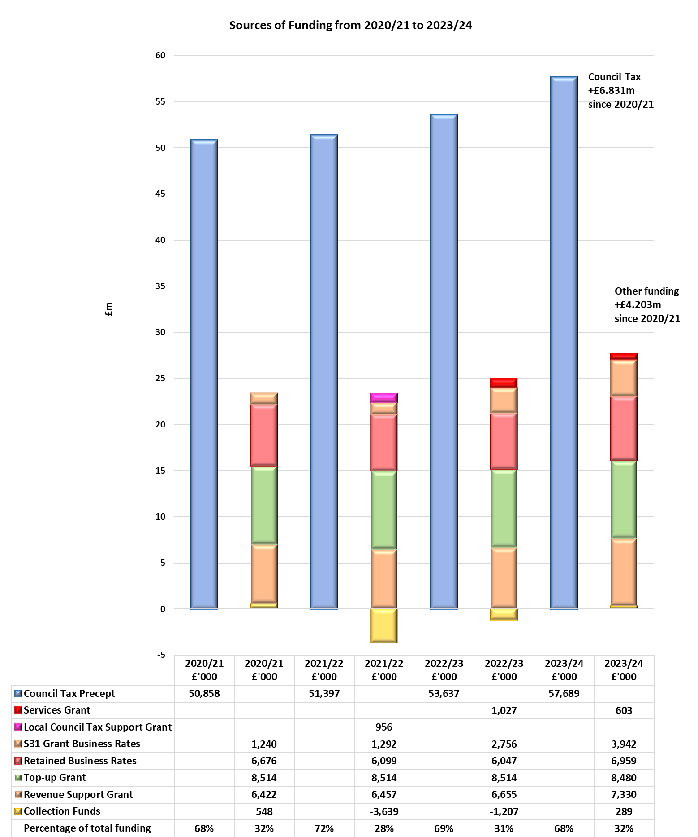
FUNDING THE 2023/24 REVENUE BUDGET

Council Tax and Business Rate Income – Additional Information

Council Tax Base - The Authority’s tax base is the sum of the tax bases of the 12 Kent District Councils and Medway Council (billing authorities), and is expressed as the number of equivalent Band D properties. The Council Tax base has increased by 1.46% for 2023/24.
Council Tax Referendum Limits - In recent years the Government has set a cap on the amount by which a local authority can increase its Council Tax each year. For 2023/24 Fire and Rescue Authorities will have the flexibility to increase the Band D Council Tax charge by up to £5 i.e. an increase of £5 or more would require a referendum. That equates to a 6.01% increase.
Household Council Tax - To arrive at the annual Council Tax charge that is made to each household, the Authority’s Council Tax charge is added on to the charges set by Kent County Council or Medway Council, plus the charges set by the relevant District Council, Kent Police and if applicable the Parish or Town Council charge. The total is then collected by the District Councils and Medway Council (billing authorities), on behalf of all the different precepting authorities.
Council Tax Increase – The proposed council tax increase set out in this MTFP is 6.01% for 2023/24. This equates to an annual increase of £4.95 (just under 10 pence per week), increasing the Council Tax for a Band D property to £87.30 for 2023/24.

FUNDING THE 2023/24 REVENUE BUDGET
Council Tax and Business Rate Income – Additional Information
The Table below shows a breakdown of the funding sources for the 2023/24 budget and the amount of this Authority’s Council Tax charge by Council Tax band:-
 | £’000 | £’000
Net Revenue Budget Requirement 2023/24 |  | 85,292
Funding:
Council Tax | 57,689
Services Grant | 603
Revenue Support Grant | 7,330
Top–up Grant | 8,480
Retained Business Rates | 6,959
Net Surplus on Collection Funds (see page 13) | 289
Section 31 Business Rates Relief Grant | 2,498
Section 31 Compensation for Under-Indexation of Top-Up Grant | 1,444
Total Funds Available 2023/24 |  | 85,292
Council Tax Base for 2023/24 |  | 660,815
Tax charge for a Band D property in 2023/24 |  | £87.30
Annual increase in Band D charge from 2022/23 to 2023/24 |  | £4.95

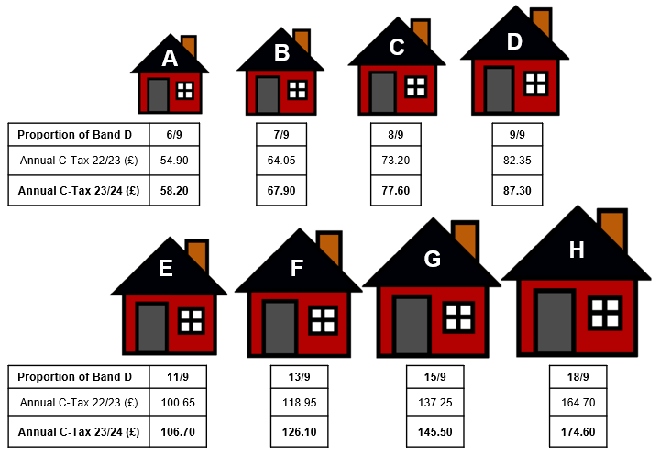

REVENUE RESERVES SUMMARY

Details of the Authority’s General Reserve and each Earmarked Reserve are given below:-
General Reserve - Provides a contingency to cushion the impact of unexpected events or exceptional costs, and in extreme circumstances would be used to provide a working cash balance to cushion the impact of uneven cash flows, and help avoid unnecessary temporary borrowing. For example, the General Reserve could be used to fund any unforeseen loss on the Authority’s share of Kent District’s and Medway Council’s Business Rate collection funds. Within the 2023/24 Reserve Strategy, it is proposed that the level of General Reserve is set at approximately 5% of the Authority’s base revenue budget. The appropriateness of this level is assessed on an annual basis, through a detailed risk assessment.
Earmarked Reserves - Sums specifically set aside not only provide funds to meet future known or predicted expenditure or liabilities, but also support the transformation of the service to ensure it is fit for the future. Earmarked Reserves are typically used to smooth the impact on the revenue budget (and Council Tax) of expenditure that would otherwise cause significant fluctuations in the annual budget requirement, such as expenditure on the replacement of vehicles and equipment. Earmarked Reserves are also of use where there may be plans to introduce a policy change or a service improvement which initially requires a one-off increase in expenditure for which additional resources are required, or where there is a future budget liability or pressure which is known, but for which the timing of payments or change in funding is uncertain. The purpose of each reserve is clearly defined, with regular reviews to ensure continued relevance and adequacy.
- Government Grants - Used to carry forward unspent Government grants.

- Infrastructure - Used to fund revenue and capital investment in infrastructure assets (premises, IT, vehicles and operational equipment) and reflects funding for a significant programme of investment in these areas over the medium-term.

- Insurance and Resource - Used to smooth the impact of insurance claims volatility and the annual variability in legal costs in relation to the enforcement of building safety regulations. The reserve will also be used to support significant one-off costs that may arise, for example for higher levels of pay awards, compared to that planned for in the MTFP or significant increases in inflation in some areas of supplies, which again may arise after the budget is agreed. Future funding levels currently remain highly uncertain so this reserve may be required to temporarily balance the budget where there is a timing difference in cuts to funding and the delivery of base budget savings.

- Rolling Budget - Used to fund committed expenditure where the goods or services will not be received or delivered until the following financial year.

- Service Transformation and Productivity - Used as a one-off funding resource to help pump-prime new transformation initiatives or improvements to the Service which may arise in-year or be planned for future years, as set out in the relevant Strategies. It will also be used to help support collaborative initiatives with other blue light services and partner agencies, and fund a number of fundamental reviews across the Service which will help ensure that it stays fit for the future.
REVENUE AND CAPITAL RESERVES SUMMARY
The Table below shows the forecast closing revenue reserve balances along with the estimated closing capital receipts balances for the years 2022/23 to 2026/27. Figures exclude any transfer from reserves that may be required at year end as a result of the forecast overspend on the 2022/23 revenue budget.
General and Earmarked Reserves - Forecast Balances  (All figures are £’000) | 31/03/23  Forecast Balance | 31/03/24  Forecast Balance | 31/03/25  Forecast Balance | 31/03/26  Forecast Balance | 31/03/27  Forecast Balance
General Reserve | 3,970 | 4,260 | 4,430 | 4,520 | 4,640
Earmarked Reserves:
Government Grants | 1,105 | 467 | 347 | 347 | 0
Infrastructure | 24,992 | 22,546 | 13,623 | 8,173 | 9,927
Insurance and Resource | 3,800 | 3,800 | 3,800 | 3,800 | 3,800
Rolling Budgets | 216 | 0 | 0 | 0 | 0
Service Transformation & Productivity | 467 | 293 | 0 | 0 | 0
Total Earmarked Reserves | 30,580 | 27,106 | 17,770 | 12,320 | 13,727
Total General and Earmarked Reserves | 34,550 | 31,366 | 22,200 | 16,840 | 18,367
Capital Receipts Reserve | 9,855 | 6,489 | 0 | 0 | 0
Total Reserves | 44,405 | 37,855 | 22,200 | 16,840 | 18,367
Net Change in Total Reserves | (6,386) | (6,550) | (15,655) | (5,360) | 1,527

Breakdown of forecast Government Grant balance as at 31.03.2023:
Grant: | £’000
National Resilience and New Threats | 312
Building Risk Review and Protection Uplift | 70
Emergency Services and Mobile Communication Programme | 347
Fire Pensions Administration – McCloud / Sargeant Remedy | 142
75% Local Tax Income Guarantee Grant | 234
Estimated Total Government Grants Remaining at 31.03.2023 | 1,105

MEDIUM TERM FINANCIAL PLAN 2023/24 – 2026/27

Revenue Budget Assumptions (Funding, Pressures and Savings)

The revenue budget funding for 2024/25 to 2026/27 is estimated using various assumptions, as much of the information required to set the medium-term budget is not yet known. As detailed previously, the Government has only confirmed funding for 2023/24 (with some guiding principles for 2024/25). On that basis a prudent approach has been taken in estimating funding that may be received from central Government in future years. Details of the main assumptions used in estimating the revenue budgets for 2024/25 to 2026/27 are detailed below:-
The main funding assumptions at this point in time are:-
- The Settlement Funding Assessment (Revenue Support Grant, Baseline Business Rates and Top-up Grant) will increase in line with inflation each year. A prudent estimate of 4% has been used for 2024/25 and the Government target rate of 2% has been used for each year thereafter.
- The Services Grant (£603k for 2023/24) will be received in 2024/25 but will be discontinued thereafter.
- A prudent estimate that the Council Tax base will increase by 1.5% in 2024/25 and 1.0% in 2025/26 and 2026/27.
- The Council Tax charge will increase by 2.99% in 2024/25, 1.90% in 2025/26 and 1.97% in 2026/27.
- There will be no surplus or deficit on the Collection Funds for 2024/25 to 2026/27.
Once further clarity is available on the level of funding available in future years, the scale of the savings that the Authority needs to make may change.
Anticipated Budget Pressures:
(All figures are £’000) | 2024/25 |  | 2025/26 | 2026/27
 | Budget |  | Budget | Budget
2% pay award for all staff groups in each year | 1,477 |  | 1,517 | 1,559
Green Book staff increments | 170 |  | 170 | 170
Bank holiday pay adjustment | 0 |  | 50 | 102
Other additional pay costs |  | 253 | 0 | 0
Actuarial valuation - LGPS | 157 |  | 157 | 0
Actuarial valuation – Fire Pensions | 0 |  | 917 | 0
Annual inflation each year | 635 |  | 381 | 390
Pressures identified from spending plan review | 949 |  | 504 | 562
Apprenticeship Levy | 9 |  | 9 | 9
Borrowing Costs | 643 |  | -20 | 0
Total Pressures | 4,293 |  | 3,685 | 2,792

MEDIUM TERM FINANCIAL PLAN 2023/24 – 2026/27

Anticipated Budget Savings:
(All figures are £’000) | 2024/25 | 2025/26 | 2026/27
 | Budget | Budget | Budget
Bank holiday and other pay adjustments | -94 | -51 | 0
Ill health pensions (2 new ill health retirements each year) | -68 | -41 | 0
Price increases not given to areas of discretionary spend | -305 | -159 | -162
Savings identified from spending plan review | -622 | -1,074 | -4
Other savings to be identified | 0 | -617 | -290
Total Savings | -1,089 | -1,942 | -456
Other Savings to be Identified - The MTFP is currently showing that £907k of unidentified base budget savings are required to balance the budget in 2025/26 and 2026/27. As funding levels beyond 2024/25 are highly uncertain the timing and amounts may change as and when future funding levels are confirmed.

Summary Revenue Budget Estimates
The Table below summarises the base budget changes in each of the financial years between 2023/24 and 2026/27. Also shown is a breakdown of funding sources and additional information with regards to increases in Council Tax receipts for the same years:-
(All figures are £’000) | 2023/24 | 2024/25 | 2025/26 | 2026/27
 | Budget | Budget | Budget | Budget
Base Budget brought forward | 79,408 | 85,236 | 88,440 | 90,183
Pay, Pensions, Prices and Pressures | 9,445 | 4,293 | 3,685 | 2,792
Savings | -3,617 | -1,089 | -1,942 | -456
Base Budget carried forward | 85,236 | 88,440 | 90,183 | 92,519
Transfers from Earmarked Reserves – see page 3 | -234 | 0 | 0 | 0
Transfer to General Reserve | 290 | 170 | 90 | 120
Net Revenue Budget | 85,292 | 88,610 | 90,273 | 92,639
Net change £ | 7,863 | 3,318 | 1,663 | 2,366
Net change % | +10.15% | +3.89% | +1.88% | +2.62%
Budget funded by:-
Council Tax | 57,689 | 60,305 | 62,066 | 63,919
Services Grant | 603 | 603 | 0 | 0
Revenue Support Grant | 7,330 | 7,623 | 7,776 | 7,931
Business Rates Baseline/Growth | 6,959 | 7,260 | 7,405 | 7,553
Top-up Grant | 8,480 | 8,819 | 8,996 | 9,176
Net Surplus on Collection Funds | 289 | 0 | 0 | 0
Section 31 Business Rates Grant | 3,942 | 4,000 | 4,030 | 4,060
Total Funding | 85,292 | 88,610 | 90,273 | 92,639

MEDIUM TERM FINANCIAL PLAN 2023/24 – 2026/27

Analysis of Additional Council Tax Income

 | 2023/24  Actual | 2024/25  Estimate | 2025/26  Estimate | 2026/27  Estimate
Council Tax Base | 660,815 | 670,727 | 677,434 | 684,209
Council Tax Base Growth % | 1.46% | 1.50% | 1.00% | 1.00%
Council Tax Base Growth £’000 | 781 | 865 | 603 | 621
Council Tax Band D Charge £ | 87.30 | 89.91 | 91.62 | 93.42
Council Tax Band D Charge Increase % | 6.01% | 2.99% | 1.90% | 1.97%
Council Tax Band D Charge Increase £ | 4.95 | 2.61 | 1.71 | 1.80
Council Tax Charge Increase £’000 | 3,271 | 1,751 | 1,158 | 1,232
Additional Income from Council Tax £’000 | 4,052 | 2,616 | 1,761 | 1,853

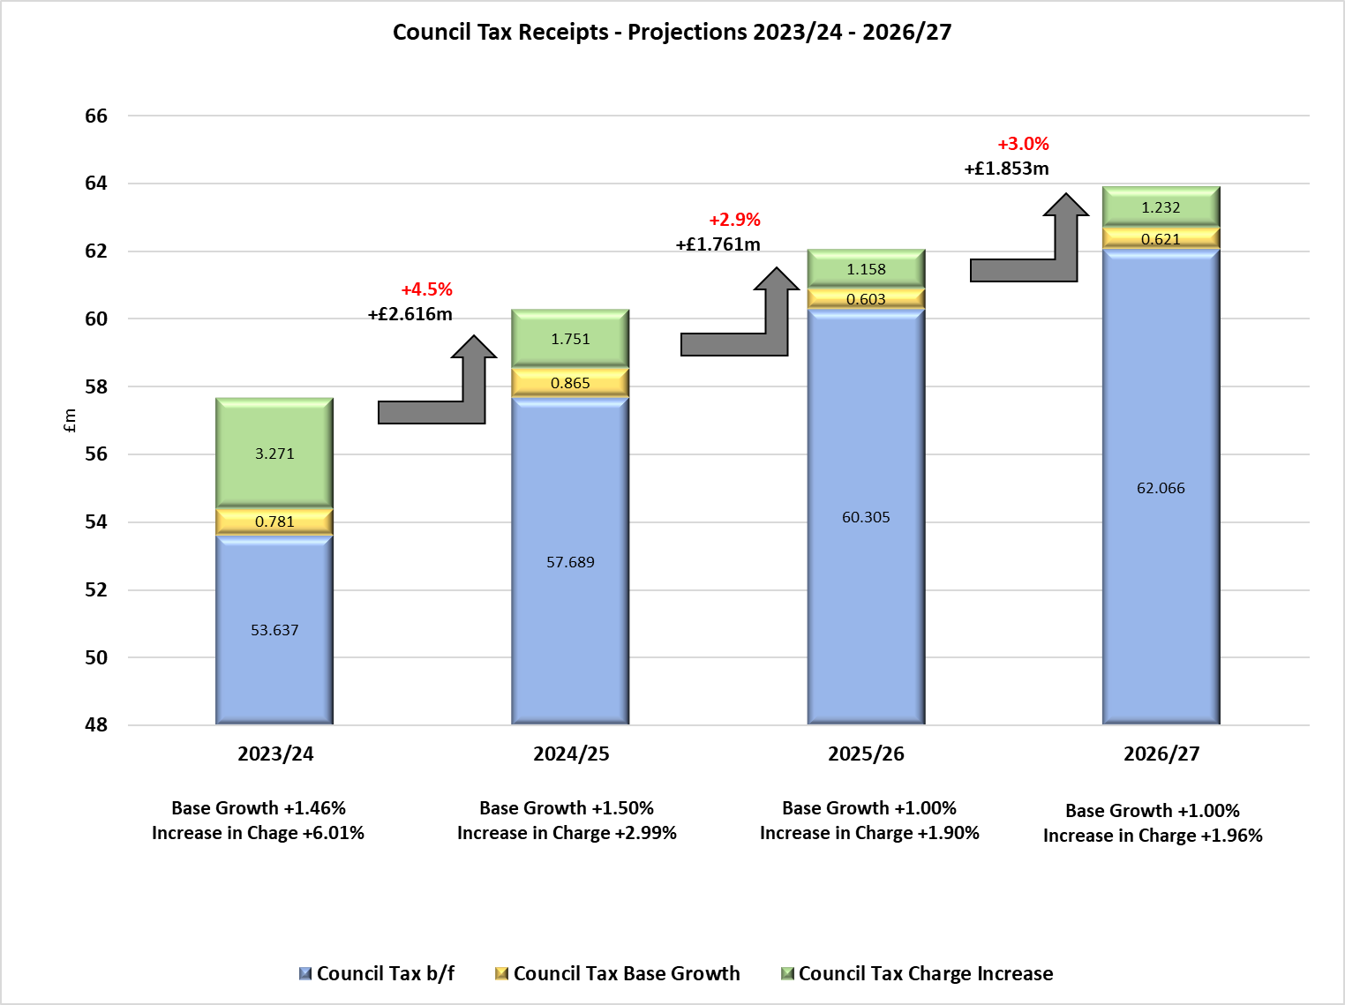
MEDIUM TERM INFRASTRUCTURE PLAN 2023/24 - 2026/27

Medium Term Infrastructure Plan – Capital and Revenue

Capital Expenditure Plan
The Capital Plan has been developed in line with the proposals detailed in the Customer Safety Plan and supporting corporate strategies, to improve and maintain key assets and infrastructure across the organisation. The main areas contained within the Plan are detailed below:-
Building works - A programme of refurbishment and improvements across the estate is in place to not only ensure that the Service and its operational bases remain fit for the future but also to improve efficiency to enable us to achieve carbon neutrality by 2030. Current reviews for the Maidstone site and Road Safety building at Rochester are ongoing. Indicative funding requirements have been incorporated into the capital programme, to ensure that any redevelopments can be afforded. Redevelopment of the Ashford site, including the Live Fire training facility, is underway and it is expected to be completed towards the end of 2023/24.
We are now looking to take vehicle maintenance and repairs in-house and expect to finalise the leasing of a suitable property in 2023/24.

Vehicle replacements - There is a comprehensive long-term programme in place for the replacement of the operational fleet of fire engines, specialist vehicles, pool and response cars which is reviewed on a regular basis to determine any change in the numbers and types of vehicles that may be needed to facilitate operational capability identified in the Customer Safety Plan. Alongside the dual fuel vehicles recently purchased we have now taken delivery of 36 self-charging hybrid vehicles. We will continue to consider, where appropriate to do so, more eco-friendly products as they become available. We are expecting delivery of 5 new Rescue Pumps in 2023/24 with a further 44 to be delivered over the following 2 years.

Mobile Data Terminals - This is an operational response IT project to install data terminals in all fire engines and response vehicles as well as Satnavs and tracking devices and is due to be completed during 2023/24.
Revenue Expenditure Plan
One-off expenditure in relation to premises, IT and operational equipment that does not meet the criteria for capitalisation is funded from the Infrastructure Revenue Plan.
Premises - The Plan contains funding for climate works, security upgrades and fire compartmentation works. Works on the site for Control are due to complete in 2023/24.
IT - There is significant investment planned for IT including expenditure on key internal support systems such as Fleet and Operation Equipment management systems, responsive operational systems such as Command and Control; systems that underpin the pro-active work of the organisation such as Operational Response (CRM); plus expenditure on underlying core IT infrastructure such as replacement mobile equipment.
Equipment – There are plans to upgrade various items of operational equipment in the near future including Breathing Apparatus.
MEDIUM TERM INFRASTRUCTURE PLAN 2023/24 – 2026/27
Medium Term Infrastructure Plan - Expenditure

The Tables below detail the capital and revenue infrastructure spend provisionally planned between 2023/24 and 2026/27:-

Capital Infrastructure Programme

(All figures are £’000) |  | 2023/24 | 2024/25 | 2025/26 | 2026/27 | 2023-27
 |  | Budget | Budget | Budget | Budget | Total
Future Station Development |  | 11,570 | 2,301 | 800 | 800 | 15,471
Vehicle Maintenance Unit Lease |  | 1,260 | 0 | 0 | 0 | 1,260
Total Station Development |  | 12,830 | 2,301 | 800 | 800 | 16,731
Roofing Works |  | 160 | 238 | 171 | 150 | 719
Drill Towers |  | 0 | 0 | 0 | 100 | 100
Boilers / Heat Pumps |  | 110 | 722 | 50 | 50 | 932
Generators |  | 0 | 69 | 20 | 20 | 109
Total Premises |  | 270 | 1,029 | 241 | 320 | 1,860
Operational Response Project |  | 158 | 530 | 0 | 0 | 688
Total Systems |  | 158 | 530 | 0 | 0 | 688
Pumps |  | 1,346 | 0 | 0 | 0 | 1,346
Rescue Pumps |  | 0 | 10,523 | 4,537 | 0 | 15,060
Light Fleet (Cars and Vans) |  | 114 | 658 | 0 | 187 | 959
Specialist Vehicles |  | 1,774 | 1,272 | 492 | 42 | 3,580
Total Vehicles & Appliances |  | 3,234 | 12,453 | 5,029 | 229 | 20,945
Total Capital Expenditure |  | 16,492 | 16,313 | 6,070 | 1,349 | 40,224
* A ten-year capital programme is detailed in the Capital Strategy
Revenue Infrastructure Programme

(All figures are £’000) |  | 2023/24  Budget | 2024/25  Budget | 2025/26  Budget | 2026/27  Budget | 2023-27  Total
Premises |  | 235 | 208 | 28 | 0 | 471
IT |  | 3,150 | 2,278 | 3,074 | 1 | 8,503
Vehicles and Equipment |  | 806 | 2,192 | 150 | 795 | 3,943
Total Revenue Expenditure |  | 4,191 | 4,678 | 3,252 | 796 | 12,917
Total Revenue and Capital |  | 20,683 | 20,991 | 9,322 | 2,145 | 53,141

MEDIUM TERM INFRASTRUCTURE PLAN 2023/24 – 2026/27
Medium Term Infrastructure Plan - Expenditure

The Chart below details the capital and revenue infrastructure spend provisionally planned between 2023/24 and 2026/27:-

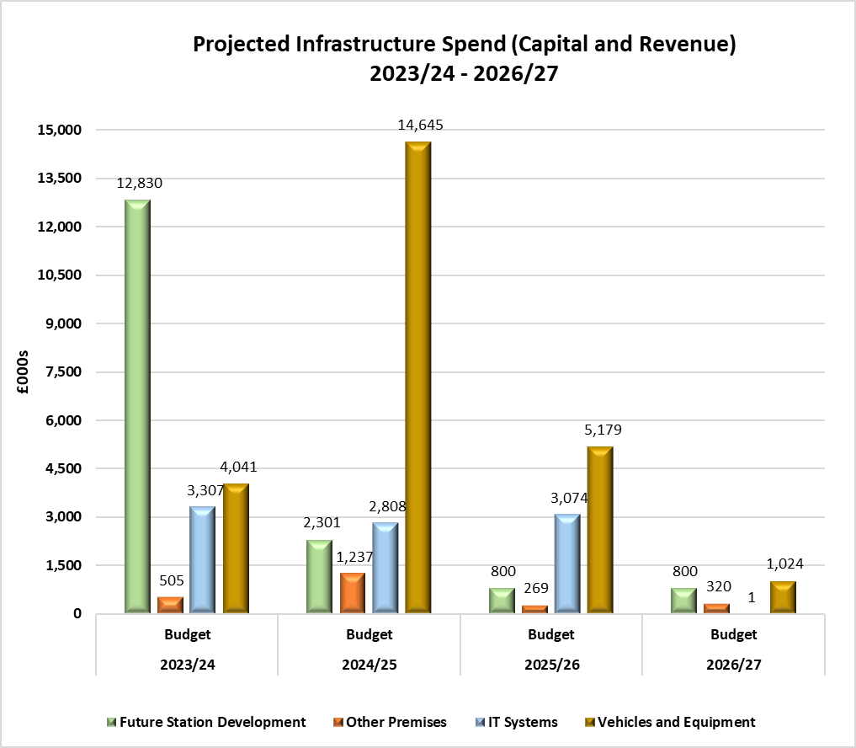

MEDIUM TERM INFRASTRUCTURE PLAN 2023/24 – 2026/27

Infrastructure Plan - Funding and Reserve Balances

The Infrastructure Plan is funded from various sources, each described below:-
Revenue Contributions / Reserves - The base revenue budget has a level of funding which is used to support the funding of both the revenue and capital infrastructure plans. If all of this resource is not used in-year, then it is carried forward in the Infrastructure Reserve for use in future years. The Infrastructure Reserve is used to fund revenue and capital investment in infrastructure assets to ensure continuous development and improvement across the organisation.
Capital Receipts - The use of capital receipts from the disposal of assets is governed by Regulations and can only be used to fund capital expenditure and repay debt. Where properties are identified as surplus to operational requirements, Members approval is sought for their disposal. Cash receipts which are generated from the asset disposal and which are in excess of £10k, must be used to support new capital investment or offset future debt or transitional costs. They cannot be used to fund day to day revenue expenditure. As at 31 March 2023 there are forecast to be unapplied capital receipts arising from the disposal of a number of the Authority’s assets, including redundant fire stations, land and unoccupied housing of £9.855m.
Prudential Borrowing - The Authority can use prudential borrowing to fund capital expenditure provided that such borrowing is affordable, prudent and sustainable over the medium term. A range of calculations (prudential indicators) are completed as part of the annual budget setting process to evidence this. These make sure that the cost of paying for interest charges and the repayment of principal is taken into account when developing the Medium Term Financial Plan.
Internal borrowing will be used to finance the Ashford Fire Station Redevelopment project with a view to potentially undertaking external borrowing in later years. Internal borrowing requires an amount to be set aside in the revenue budget (Minimum Revenue Provision) to repay the principal amount and although interest charges will not be incurred on internal borrowing it will result in reduced investment income as the funds will no longer be available to invest.

MEDIUM TERM INFRASTRUCTURE PLAN 2023/24 – 2026/27
Infrastructure Plan - Funding and Reserve Balances
The Tables below show the funding sources for the capital plan plus anticipated balances on the capital receipts and infrastructure reserves for 2023/24 to 2026/27.
Capital Infrastructure Plan Funding
(All figures are £’000) |  | 2023/24  Budget |  | 2024/25  Budget |  | 2025/26  Budget |  | 2026/27  Budget | 2023-27  Total
Funded By:
Revenue Contributions - from Base Budget |  | 2,592 |  | 2,592 |  | 2,592 |  | 2,592 | 10,368
Revenue Contributions – (to) / from Reserve |  | (496) |  | 5,497 |  | 3,478 |  | (1,243) | 7.236
Internal Borrowing |  | 11,030 |  | 1,501 |  | 0 |  | 0 | 12,531
Capital Receipts Applied |  | 3,366 |  | 6,723 |  | 0 |  | 0 | 10,089
Total Funding |  | 16,492 |  | 16,313 |  | 6,070 |  | 1,349 | 40,224
Revenue Infrastructure Plan Funding
(All figures are £’000) |  | 2023/24  Budget |  | 2024/25  Budget |  | 2025/26  Budget |  | 2026/27  Budget | 2023-27  Total
Funded By:
Revenue Contributions - from Base Budget |  | 1,200 |  | 1,252 |  | 1,280 |  | 1,307 | 5,039
Revenue Contributions – (to) / from Reserve |  | 2,941 |  | 3,426 |  | 1,972 |  | (511) | 7,828
One off funding |  | 50 |  | 0 |  | 0 |  | 0 | 50
ESMCP (ESN) Grant |  | 0 |  | 0 |  | 0 |  | 0 | 0
Total Funding |  | 4,191 |  | 4,678 |  | 3,252 |  | 796 | 12,917

Capital Receipts Reserve
(All figures are £’000) | Forecast  31.3.23 | Forecast  31.3.24 |  | Forecast  31.3.25 |  | Forecast  31.3.26 |  | Forecast  31.3.27
Balance at end of year | 9,855 | 6,489 |  | 0 |  | 0 |  | 0

Infrastructure Reserve

(All figures are £’000) | 2023/24  Forecast | 2024/25  Forecast | 2025/26  Forecast | 2026/27  Forecast
Balance at start of year (1 April) | 24,992 | 22,546 | 13,623 | 8,173
Infrastructure reserve – capital movements | 496 | -5,497 | -3,478 | 1,243
Infrastructure reserve - revenue movements | -2,941 | -3,426 | -1,972 | 511
Balance at end of year (31 March) | 22,546 | 13,623 | 8,173 | 9,927

